Key Project Information & project Design Document (PDD)

PUBLICATION DATE 14.10.2020
VERSION v. 1.2
RELATED SUPPORT

- TEMPLATE GUIDE Key Project Information & Project Design Document v.1.2

This document contains the following Sections
Key Project Information
SECTION A – Description of project
SECTION B - Application of approved Gold Standard Methodology (ies) and/or demonstration of SDG Contributions
SECTION C – Duration and crediting period
SECTION D – Summary of Safeguarding Principles and Gender Sensitive Assessment
SECTION E – Outcome of Stakeholder Consultations
Appendix 1 – Safeguarding Principles Assessment (mandatory)
Appendix 2 - Contact information of Project participants (mandatory)
Appendix 3 - LUF Additional Information (project specific)
Appendix 3 - Summary of Approved Design Changes (project specific)

KEY PROJECT INFORMATION
GS ID of Project | GS11438
Title of Project | SOLVATTEN Solar Safe Water Heater Kenya
Time of First Submission Date | 01/12/2021
Date of Design Certification | 26/10/2023
Version number of the PDD | 13
Completion date of version | 13-12-2023
Project Developer | Solvatten AB
Project Representative | Solvatten AB
Project Participants and any communities involved | Solvatten AB
Host Country | Republic of Kenya
Activity Requirements applied | Community Services Activities  Renewable Energy Activities  Land Use and Forestry Activities/Risks & Capacities  N/A
Scale of the project activity | Micro scale  Small Scale  Large Scale
Other Requirements applied | -
Methodology (ies) applied and version number | Emission Reductions from Safe Drinking Water Supply v1.0
Product Requirements applied | GHG Emissions Reduction & Sequestration  Renewable Energy Label  N/A
Project Cycle: | Regular  Retroactive

Table 1 – Estimated Sustainable Development Contributions
Sustainable Development Goals Targeted | SDG Impact  (Defined in B.6.) | Estimated Annual Average | Units or Products
13 Climate Action | Emission Reductions | 23 902 | VERs
1 No Poverty | Number of households reporting reduced expenses on fuel and medical | 13 860 | Households
3 Good health and well being | Number of households reporting improved health | 13 860 | Households
5 Gender Equality | Number of households reporting time saved on cooking and fuel collection | 13 860 | Households
6 Clean Water and Sanitation | Total additional number of households with access to safe water supply | 15 306 | Households
7 Affordable and clean energy | Displaced Non-Renewable Energy in MWh | 47 402 | MWh
15 Life on land | Total Weight Saved of Non-Renewable Biomass | 17 873 | tonne

SECTION A. DESCRIPTION OF PROJECT

A.1 Purpose and general description of project
The project SOLVATTEN Solar Safe Water Heater Kenya further referred to as the project activity, is based on the distribution of the SOLVATTEN Solar Safe Water Heater further referred to as SOLVATTEN, by Swedish company Solvatten AB further referred to as the project developer. The use of SOLVATTEN displaces the baseline use of non-renewable biomass and fossil fuels to treat drinking water, thus resulting in Emissions Reductions. The use of SOLVATTEN also helps households reduce fuel and medical expenditures, improves end-user health by cleaner indoor air and safe water access, saves time on chores such as fuel collection and cooking typically performed by women, utilises free renewable solar energy and reduces local demand pressure on unsustainable biomass.

Location of the project activity
SOLVATTEN will be distributed to rural household end-users in the host country Kenya. Distribution registry will contain the location of every distributed SOLVATTEN. More detailed information and table of current counties with respective coordinates.in A.2.

Technology
SOLVATTEN is a point-of-use unit for UV disinfection and solar water heating to supply safe drinking water. It is a highly efficient water purifier that treats water from bacteria, cysts, and viruses. Solvatten is designed to heat water and to supply safe drinking water for a family for more than seven years without maintenance costs or changing parts, no need for added chemicals or use of electricity or batteries. More detailed information in A.3.

Project boundary
The project boundary includes the physical, geographical sites of the zero-greenhouse gas emitting technology to treat and heat safe drinking water installed by the project activity, these sites are the households where the end users of safe water provided by the project are located. More detailed information and table of included GHGs in B.3.

Baseline scenario
    - The baseline scenario for this project is the practice of boiling water for household consumption. More detailed information and results from the Baseline Survey in B.4.
Eligibility of the project under Gold Standard
Eligibility criteria | Justification
Project type  Section 4.1.3 of the GS4GG PAR v 1.2  A Project type is automatically eligible for Gold Standard Certification if there are Gold Standard approved Activity Requirements and/or Impact Quantification Methodologies associated with it, or it’s referenced in the Gold Standard Product Requirements.  Section 3.1.1 of the Community Services Activity Requirements (CSA) v 1.2  Pre-identified CSA project types are noted below.  [...]  (d) Water, sanitation and hygiene (WASH): WASH activities contributing to climate change mitigation and/or adaptation benefits.  Section 5.1.1 of the GHG Emission Reductions & Sequestration Product requirements v 2.0  The Following Project types are eligible for issuance of GSVERs or GSCERs:  [...] a. Renewable Energy Supply: Project activities that generate and deliver energy services (e.g., mechanical work/electricity/heat) from non-fossil and renewable energy sources. Note that specific requirements apply with regards to the issuance of Gold Standard Labelled Renewable Energy GSCERs and GSVERs, as listed in section 2 of the Renewable Energy Activity Requirements. | The project is based on providing a WASH service, contributing to climate change mitigation by displacing non-renewable energy. Therefore, the project is automatically eligible for Gold Standard Certification through being pre-identified as a CSA project type in section 3.1.1 d) in the CSA v1.2.  The project activity uses solar energy and solar UV radiation to heat and treat water. It delivers energy services from a non-fossil and renewable energy source and is therefore eligible for issuance of GS VERs according to the GHG Emission Reductions & Sequestration Product requirements v 2.1. As the technology is not grid-connected, used at a household level, and the project is not planning to issue “Gold Standard Labelled Renewable Energy GSVERs”, the specific requirements from the Renewable Energy Activity Requirements are not applicable.
Location of projects  Section 3.1.1 of the GS4GG PAR v 1.2  Projects may be located in any part of the world.  Section 3.1.1 GHG Emission Reductions & Sequestration Product requirements v 2.0  VER Projects may be located in any host country or state. | Project is located in the host country of Kenya
Project Area, Project Boundary and Scale  Section 3.1.1 of the GS4GG PAR v 1.2  The Project Area and Project Boundary shall be defined. Projects may be developed at any scale although certain rules, requirements and limitations may apply under specific Activity Requirements, Impact Quantification Methodologies and Products Requirements.  In order to avoid double counting the Project shall not be included in any other voluntary or compliance standards programme unless approved by Gold Standard (for example through dual certification). Also, if the Project Area overlaps with that of another Gold Standard or other voluntary or compliance standard programme of a similar nature, the project shall demonstrate that there is no double counting of impacts at design and performance certification (for example use of similar technology or practices through which the potential arises for double counting or misestimation of impacts amongst projects).  Section 3.1.2 of the Community Services Activity Requirements (CSA) v 1.2  Project area, boundary and scale: Project Area and Boundary shall be defined in line with the applicable Impact Quantification Methodologies and Product Requirements.  Section 9.1.1 GHG Emission Reductions & Sequestration Product requirements v 2.0  GSVER Projects may be registered as ‘large scale’, ‘small scale’ (for the  applicability of methodologies and tools only) or ‘microscale’. Scale is defined  in the relevant Activity Requirements or where these do not exist then per  following paragraphs. | The project is not included in any other voluntary or compliance standards programme.  Project calculations includes recurring monitoring of the factor Cb, which is used to disqualify end-users that already use a safe water supply before this project intervention. Therefore, no impacts from other projects will be double counted in this project. In order to maximize the positive impacts of the project, the criterion for selecting recipients aims to filter out potential end-users who already has access to a safe water supply other than boiling.  Project Area and boundary is defined in line with the Emissions Reductions from Safe Drinking Water Supply v 1.0 and the GHG Emission Reductions & Sequestration Product requirements v 2.1.  Project scale is small scale (Type 3 activity) according to Section 9.1.2 GHG Emission Reductions & Sequestration Product requirements v 2.1 as it involves Safe water supply, and estimates emissions reductions under 60 000 tCO₂ per year.
Host country requirements  Section 3.1.1 of the GS4GG PAR v 1.2  Projects shall be in compliance with applicable Host Country’s legal, environmental, ecological and social regulations.  3.1.1 of the GHG Emission Reductions & Sequestration Product requirements v 2.0  VER Projects may be located in any host country or state. However, where host countries or states have mandatory operational schemes to reduce GHG emissions in any form (e.g. cap & trade, carbon tax etc.), Projects shall only be eligible if the Project Developer has either:  a. provided Gold Standard with satisfactory justification that no double counting of emission reductions occur or  b. has committed to retiring eligible units equal to the quantity of Gold Standard VERs. Refer to Annex A of this document. | Solvatten, including local partners, are following employment laws and regulations in the country they are active. All enlisted Local partners are registered Companies or NGOs in Kenya.  The product specification is in line with Kenyan standards for Water treatment systems, and every import is monitored and approved by Kenyan Bureau of Standards (KEBS). For more detailed info on the QA and import procedures see section A.3 of this PDD.  The project is supported by local regional-level policymakers, see letters of recommendation submitted together with this PDD.  The project developer deems the project to be in line with relevant environmental, ecological and social regulations of the host country Kenya. According to Kenya's National Water Master Plan 2030 a target for the country is “to ensure that improved water and sanitation are available and accessible to all by 2030” which is in line with the estimated impacts of this project.  The host country of Kenya does not have mandatory operational schemes to reduce GHG emissions in any form (e.g., cap & trade, carbon tax etc.).  The project is not registered with any other voluntary or compliance schemes besides GS4GG.  In it’s first Nationally determined contribution (NDC), Kenya commits to reduce it´s GHG emissions with 32% by 2030. This project is deemed to be compliant with all legal requirements, while also helping Kenya reach it´s NDC commitment.
Contact details  Section 3.1.1 of the GS4GG PAR v 1.2  As part of the Project Documentation the Project Developer shall provide (i) name and (ii) contact details of all Project Participants; AND in case of an organisation (iii) the legal registration details and (iv) documentation by the governing jurisdiction that proves that the entity is in good standing (defined as being a legal or other appropriate entity registered in or allowed to operate within the required jurisdiction and with no evidence of insolvency or legal/criminal notices placed against it or any of its Directors). | See cover letter submitted with this PDD  See Legal Registration Details submitted with this PDD
Legal Ownership  Section 3.1.1 of the GS4GG PAR v 1.2  Full and uncontested legal ownership of any Products that are generated under Gold Standard Certification, (for example carbon credits) shall be demonstrated. Where such ownership is transferred from project beneficiaries this must be demonstrated transparently and with full, prior and informed consent (FPIC).  Note that for certain Project types there is a requirement for full and uncontested legal land title/tenure to be demonstrated. These are contained within specific Activity or Product Requirements. All projects shall immediately report to Gold Standard any land title/tenure disputes arising.  Section 3.1.4 of the Community Services Activity Requirements (CSA) v 1.2  (a) Projects involving the distribution of a large number of devices for services such as heating, cooking, lighting, electricity generation, water treatment technology such as water filter, etc. shall provide a clear description of the ownership of the Products that are generated under Gold Standard Certification all along the investment chain. In line with the FPIC requirement, the proofs that end-users are aware of and willing to give up their rights on Products shall be provided.  (b) The transfer of Product ownership shall be discussed during local stakeholder consultations for projects. | The Products generated in this project are the GS VERs together with the Certified SDG contributions. The product ownership is transferred from project beneficiaries to the Project Developer with full, prior and informed consent. The local organisations cooperating with the Project Developer to distribute the systems are also informed, through their contract with the Project Developer, about the transfer of carbon credits from the end-user to the Project Developer (please refer to “Sample of end user agreement.pdf” submitted together with this PDD). Proofs that end-users are aware of and willing to give up their rights on Products are generated as the Solvatten systems are deployed and stored together with other relevant end-user details in the end–user registry. For more information, see section A.1.2. The mechanism of carbon financing and the transfer of carbon credits from the end user to the project developer was discussed at the digital and physical SCM (Please refer to the Stakeholder Consultation report submitted).
Other rights  Section 3.1.1 of the GS4GG PAR v 1.2  As well as legal title and ownership, the Project Developer shall also demonstrate where required uncontested legal rights and/or permissions concerning changes in use of other resources required to service the Project (for example, access rights, water rights etc.). Any known disputes or contested rights must be declared immediately to Gold Standard by the Project Developer and resolved prior to further project implementation in affected areas. | As the system consists of a portable 10 litre jerry-can that heats and treats water with solar energy and UV radiation, the project activity does not affect land tenure rights, water rights, access rights or alter the use of any resources or energy except for the solar energy captured by the system.
Official Development Assistance (ODA) Declaration  Section 3.1.1 of the GS4GG PAR v 1.2  All Project Developers applying for project activities located in a country named by the OECD Development Assistance Committee’s ODA recipient list and seeking Gold Standard Certification for carbon credits shall declare the Official Development Assistance (ODA) support. The Project Developer shall follow the GHG Emissions Reduction & Sequestration Product Requirements and submit the declaration at the time of Design Certification.  Section 6.1 of the GHG Emission Reductions & Sequestration Product requirements v 2.0  6.1.1 Projects are ineligible for carbon crediting under GS4GG if the OFFICIAL  DEVELOPMENT ASSISTANCE (ODA) is provided to the project under the  condition that the credits generated by the Project will be transferred, either  directly or indirectly, to the donor country providing ODA support.  6.1.2 Project Developer submitting a Project located in a country named by the  OECD Development Assistance Committee’s ODA recipient list shall sign and  submit the ODA Declaration. | The project does not receive any Official Development Assistance (ODA) support. As the project host country of Kenya is on the  OECD Development Assistance Committee’s ODA recipient list, the project developer has signed the ODA Declaration which is submitted to the verifying body together with this PDD.  The project commits to follow the GHG Emissions Reduction & Sequestration Product Requirements.
Suppressed demand  Section 3.1.3 of the Community Services Activity Requirements (CSA) v 1.2  Certain Impact Quantification methodologies allow projects to account Suppressed Demand scenario when establishing a baseline. In such cases, the application of Suppressed Demand baseline is limited to Small Scale and Microscale Projects. Where a Suppressed Demand baseline is applied, it is not possible to ‘stack’ Gold Standard Certified Impact Statements or Products as the definition of the baseline may be contradictory. | The project baseline will be determined in line with the selected impact quantification methodology, Emissions Reductions from Safe Drinking Water Supply v 1.0. As the project is small scale and will not stack Gold Standard Certified Impact Statements, a supressed demand baseline according to the methodology is applicable.
Eligible Greenhouse Gases  Section 4.1.1 of the GHG Emission Reductions & Sequestration Product requirements v 2.0  Only Carbon Dioxide (CO₂), Methane (CH₄) and/or Nitrous Oxide (N₂O) are  eligible for GSVERs or GSCERs, provided Projects comply with all GS4GG  Requirements and eligibility criteria. | For the purpose of calculating emissions reductions, only the greenhouse gases Carbon Dioxide (CO₂), Methane (CH₄) and Nitrous Oxide (N₂O) are included in the project boundary as carbon dioxide equivalents (tCO₂e). See section B.3 of this PDD for further information on the project boundary.

Regulatory Framework
Regulation | Implication | Compliance
Environmental Management  and Coordination (Water  Quality) Regulations, 2006 | Regulates the provision of drinking water, that operators and vendors shall comply to relevant water quality standards and sets limits for E coli among others. | The project complies to this through rigorous testing and verification that the equipment can provide safe water. Please refer to Technology description in section A.3 of this PDD.
Guidelines on Drinking  Water Quality and Effluent  Monitoring | The purpose of this guideline is to: Promote transparency in the methods of water quality monitoring employed by the WSPs and thus build public confidence in service provision; Ensure through regular monitoring that the quality of water provided meets the standards set by KEBS; Create awareness among the Water Services Boards (WSBs) and Water Service Providers (WSPs) on the water quality monitoring requirements; Ensure that all WSBs and WSPs follow a systematic way of water quality monitoring so as to have uniformity of the process; Ensure a minimum standard of water quality monitoring at acceptable costs; and Create awareness among consumers that information regarding water quality will be made available by the WSPs. | The product specification is in line with Kenyan standards for Water treatment systems, and every import is monitored and approved by Kenyan Bureau of Standards (KEBS). For more detailed info on the QA and import procedures see section A.3 of this PDD
The Water Act, 2016 | The purpose of this Act is to provide for the regulation, management and development of water resources and water and sewerage services in line with the Constitution. It regulates the management,  conservation, use and  control of water  resources and for the  acquisition and  regulation of rights to  use water. | The project technology is a point of use water purification system which does not alter the water sources or cause any additional water extraction. As required by the act, the project complies with relevant standards.

    - Legal ownership of products generated by the project and legal rights to alter use of resources required to service the project
The project developer Solvatten AB is the sole owner of the project and is also the technology provider. The Products generated in this project are the GS VERs and Certified SDG contributions. The project developer Solvatten AB is the sole owner of the Products generated by this project, and this ownership is uncontested. The Product ownership is transferred from project beneficiaries to the product developer with full, prior, and informed consent. Proof that end-users are aware of and willing to give up their claims on Products are generated as the Solvatten systems are deployed and the end-user confirms this by signing a receipt at the time of Distribution.
The project activity is based on the distribution of SOLVATTEN, a point-of-use household level system to heat and treat water with solar energy and UV radiation. As such, the project activity does not affect land tenure rights, water rights, access rights or alter the use of any resources or energy except for the solar energy captured by the system. These issues were discussed during both the digital and physical SCM. Please refer to the Stakeholder Consultation Reports submitted.

A.2 Location of project
The project is located in the Republic of Kenya. Specific geographic information such as region/state/province, city/town/community or street name for the location of end-users is stored in the device registry. Kenya is located in the eastern regions of Africa, bisected by the equator. The Solvatten systems will be distributed to rural households not connected to the electrical grid. The distribution is concentrated to fuel-harvesting hotspots in arid and semi-arid areas. These hotspots typically have an above average fraction of non-renewable biomass, thus maximizing the positive impact of fuel saving interventions. See following maps of arid and semi-arid lands, and the electric grid distribution. Given these criteria, the project will initially be located in the following counties in Kenya:

County | Coordinates
Kajiado | -2°00'S 36° 52’E
Kilifi | -3°40'S 39°45'E
Kitui | 1°29′S 38°23′E
Kwale | 4°10′S 39°27′E
Laikipia | 0°04'N 36°39'E
Nyeri | 0°25'N 36°56'E
Samburu | 1°10′N 36°40′E
Taita-Taveta | 3°27′S 38°24′E
Tana River | 1°30′S 40°0′E
Tharaka Nithi | 0°18′S 38°0′E
Wajir | 1.°44’N 40°04’E

Within these counties, local implementing partners help distribute the technology to household chosen according to the criteria in section A.3, Distribution. Expansion to any further areas later in the project lifetime will be followed by a design change request.
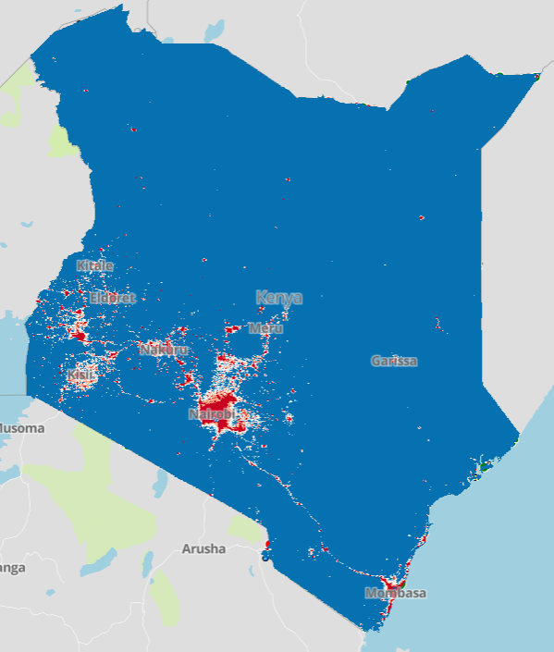
Map of Kenya showing areas with access to the electrical grid in red. Source: Energyaccessexplorer.org
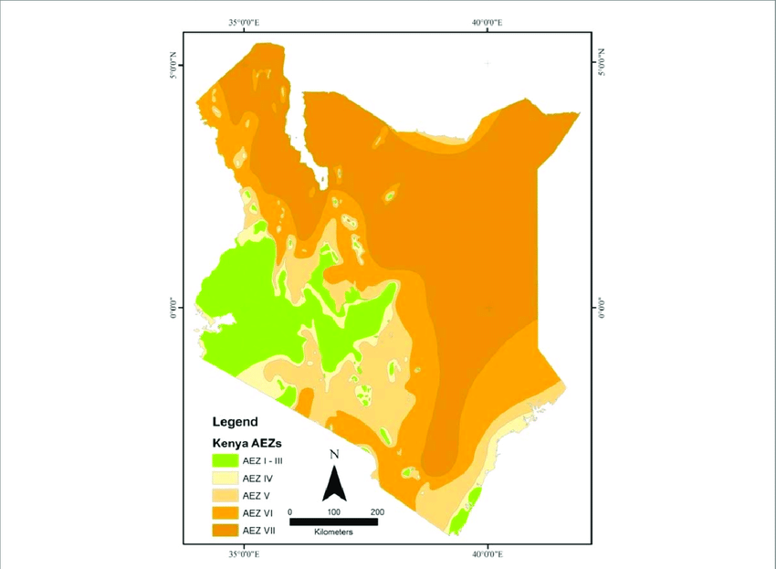
Map showing Kenya's Arid and Semi-Arid lands. Source: “Potential tropical climate-based spatio-temporal grass variability” by Kigen, C. & Muyekho F. (2019)

A.3 Technologies and/or measures
Solvatten is a highly efficient water purifier that treats water from harmful bacteria, cysts, and viruses. Solvatten is designed to heat water and to supply safe drinking water for a family for more than seven years without maintenance costs or changing parts, no need for added chemicals or use of electricity or batteries.

To date, since 2011, around 90 000 Solvatten and its SVI-10 indicator have been produced, tested and used in more than 40 countries.

Key data from the manufacturer's Product Specification (submitted with this PDD):
- The expected technical life of project technology is 7 years.
- The maximum capacity during good operational conditions is 5 liters/h.
  - This is derived from the batch volume of 10 liters/batch divided by time per batch, 2 h/batch.
- The two glazed surfaces on each unit is a total of 0.3528 m² per unit. Calculated based on the product measurements.

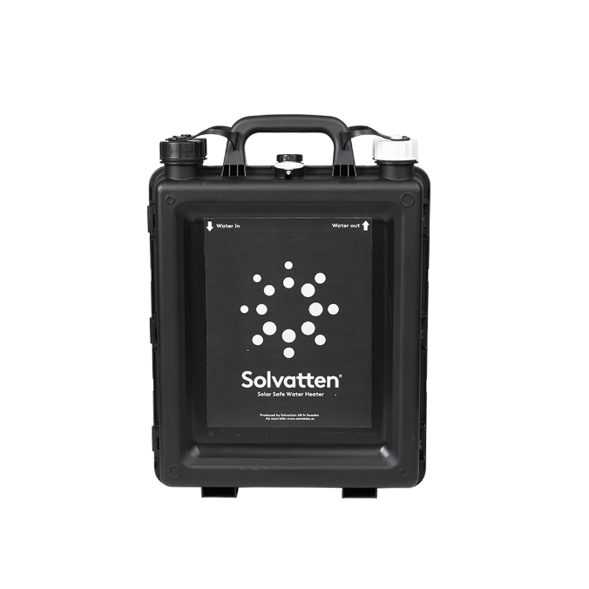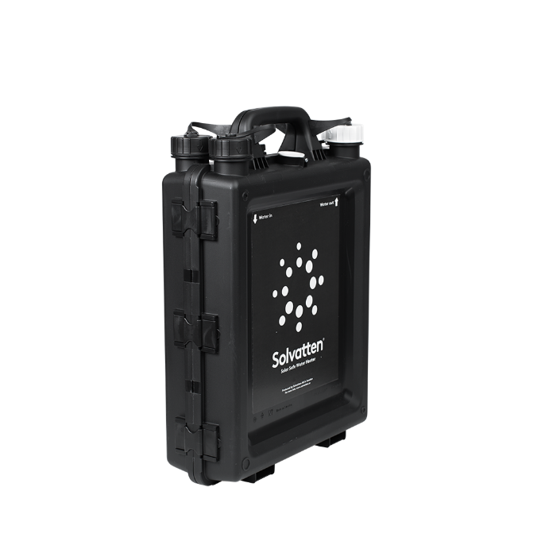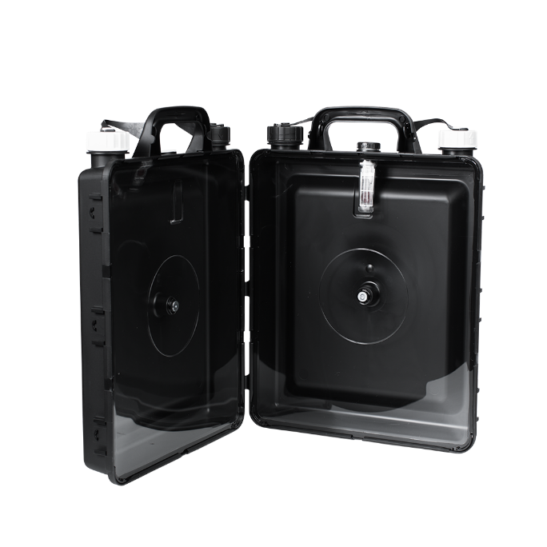
The project technology, SOLVATTEN Solar Safe Water Heater. Source: Solvatten AB

Manufacturing / QA
As Solvatten AB is both the project developer and the inventor of the project technology, this project can secure consistent and high-quality project technology. The patented product is made in Sweden, at an ISO 9001-certified manufacturer that has a long history of successful cooperation with Solvatten. The manufacturer is certified by DNV to follow ISO 9001:2015, ISO 16949:2016, ISO 14001:2015 and ISO 45001:2018. The manufacturer declares that the product complies with the US Food and Drug Administration (FDA) regulations. Each delivery to Kenya is monitored and approved by the Kenyan Bureau of Standards (KEBS) to meet the national requirements of water quality standards. In order to import the goods to Kenya, quality standards must be guaranteed both from a technological standpoint and in that the materials used are compliant with Kenyan rules and regulations. To meet these requirements Solvatten must get approval from SGS which is the verifying body for the KEBS, in the form of a Pre-export Verification of Conformity, PVoC (Please refer to the file "Issued CoC 23119A.pdf” for the latest approved PVoC). The materials used in the product has potential to be recycled.

Water treatment safety Indicator
Manufacturing of SVI-10 indicator is closely monitored to meet quality standards, and the manufacturer is ISO 9001 certified. The SVI-Indicator indicates to the end user when an ensured temperature level together with a minimum achieved irradiation level of UV-B radiation is reached, indicating that the water is safe to drink following WHO and US EPA standard for drinking water.

Technology Performance
Solvatten water treatment quality reaches the highest performance level, Comprehensive Protection according to WHO performance criteria for Household water treatment technologies. This is indicated by the “BioVir Analysis Report” submitted with the PDD, a thorough lab analysis performed by Californian BioVir Laboratories. The document “Mikrolab Analysis Report” is the results from the most recent Drinking water quality tests from 2021 performed by Mikrolab Stockholm AB certified with ISO/ IEC 17025. The tests were made according to the SS-EN ISO 9208-1:2014 standard and show the test to be acceptable according to Swedish water quality standards SLVFS 2001:30. The product is tested for and is Bisphenol-A (BPA) free: there is no leakage of Bisphenol A into the heated and UV exposed water, see attached “Microlab Analysis report BisA”.

Distribution
Solvatten is distributed at no cost to the end user. The distribution of Solvatten to the rural households is implemented by Solvatten AB’s local partners who are registered companies or Non-Governmental Organizations (NGO) in Kenya. They collaborate with local community health workers, schools and women´s groups in order to facilitate the distribution. The distribution is concentrated to fuel-harvesting hotspots in arid and semi-arid areas. These hotspots typically have an above average fraction of non-renewable biomass, thus maximizing the positive impact of fuel saving interventions. The distribution is also focused on communities not connected to the electrical grid. Collaborating with local authorities and volunteers has proved successful in creating credibility for the product, hence strengthening the sustainability of the project. In addition to focusing on off-grid, high wood fuel areas, the following criteria are agreed upon between Solvatten and the local partner (please refer to sample agreement “Agreement IAS Solvatten_Signed_2022”) for the selection of beneficiaries of the project:
- Households with children under five years
- Elderly people in the community
- Households with members with disability
- Households with members with underlying health conditions
- People without access to clean drinking water at home
- Households using low efficiency water boiling methods (eg 3-stone-fire) are prioritized
Prior to distribution, training is held with the people who are responsible for the distribution to ensure the proper handling of the product, together with hygiene and environmental education. Follow-ups with the end-users are also conducted by the staff to see how the families are using Solvatten. The registration of users is based on one registry entry per Solvatten Unit. Solvatten is normally distributed as one unit per household. In special cases, for example a household with 10 members, two units can be distributed, but the household is then registered as two separate households of 5 members each. As part of this small-scale project, the expected rate of distribution is 5 000 - 8 000 systems per year during the first 5-year cycle. The N_{p,y} and DP_{y} factors are estimated in the tables below using an expected rate of 5400 units Y1, 5900 units Y2, 6500 Y3, 7200 Y4, 7900 Y5. For further reference use the excel document “Impact Estimate.xlxs” which is submitted together with this PDD.
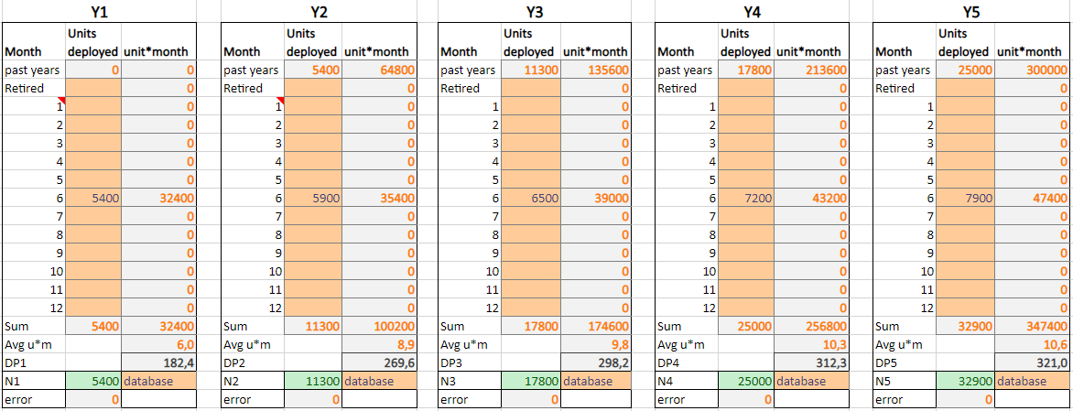The target rate of distribution for the first 5-year cycle.

Organizational structure and Current Partner Organizations
Solvatten AB has it’s main office in Stockholm, Sweden, from where a Program Manager is responsible for the project development. For distribution and information collection (surveys and samples) Solvatten cooperates with local NGOs.
Role | Organization | Registry certificate
Distribution, Surveys | International Aid Services Kenya (IAS) | X
Distribution | Child Fund Kenya | “CHILDFUND_KENYA_REGISTRATION_Certificate”
Distribution | CANCO | “CANCO registration Certificate.pdf”

Project Impact and SDG Contributions
The use of SOLVATTEN displaces the baseline use of non-renewable biomass and fossil fuels to treat and heat water for drinking and domestic use, thus resulting in Emissions Reductions (SDG 13 Impact). The use of SOLVATTEN also helps households reduce fuel and medical expenditures (SDG 1 Contribution), improves end-user health by cleaner indoor air (SDG 3 Contribution) and safe water access (SDG 6 Contribution), saves time on chores such as fuel collection and cooking typically performed by women (SDG 5 Contribution), utilises free renewable solar energy (SDG 7 Contribution) and reduces local demand pressure on unsustainable biomass (SDG 15 Contribution).

A.4 Scale of the project
In the GHG Emission Reductions & Sequestration Product requirements v 2.0, project scale is defined in Section 9.1.2. Project scale is small scale (Type 3 activity) as it involves Safe water supply and estimates emissions reductions under 60,000 tCO₂ per year.

The project estimates emission reductions between 10,000 – 60,000 tCO₂ per year during the crediting period. Should the project result in emission reductions larger than 60,000 tCO₂ any year of the crediting period, the number of VERs issued for that year is still capped at 60,000.

A.5 Funding sources of project
No public funding is received to perform the project activity.
As Kenya is on the OECD Development Assistance Committee’s ODA recipient list, a signed Official Development Assistance (ODA) Declaration is required. The signed ODA declaration is submitted together with this PDD.

SECTION B. APPLICATION OF APPROVED GOLD STANDARD METHODOLOGY (IES) AND/OR DEMONSTRATION OF SDG CONTRIBUTIONS

B.1. Reference of approved methodology
The project will use the approved Gold Standard Methodology for Emission Reductions from Safe Drinking Water Supply v 1.0 for baseline, monitoring and impact quantification. The tools and guidelines referenced in the methodology will be used when applicable e.g., the Usage Survey Guidelines from Annex 1 of the selected methodology. No standardized baselines will be used.

B.2. Applicability of methodology
Section 2.2.1 of the selected methodology lists 10 applicability conditions a-j, the project relates to these as follows:

Criteria from section 2.2.1 | Relevant | Motivation
a. Eligible household water treatment technologies (HWT), institutional water treatment technologies (IWT), and community level water treatment technologies (CWT) include bleach/chlorine, water filter (ceramic, sand, composite, membrane, etc.), UV disinfection, etc. | Yes | The project technology is a HWT based on UV disinfection and heat pasteurization, which is listed as eligible in the methodology.
b. Eligible community water supply technologies (CWS) include new installation of new borehole hand-pumps, borehole hand-pumps rehabilitation, solar powered drinking water pumps, etc. Water pumps powered by fossil-fuel engines are not eligible, with the exception of backup fossil–fuel engines that are used for no more than 10% of operating hours (parameter SWDS 33 | No | Not relevant, as the project does not employ CWS technologies.
c. All projects involving CWT and CWS technologies must also include ongoing maintenance and repair of the project technology. | No | Not relevant, as the project employs neither CWS or CWT technologies.
d. Where the project involves the rehabilitation of an existing technology, the project developer shall provide evidence that the existing technology is non-operational and that there is no planned maintenance or repair for at least 3 months after the date it became non-operational (parameter SWDS 2). | No | Not relevant, as the project does not involve rehabilitation of existing technology.
e. This methodology allows for project activities to include safe water treatment and/or supply technologies implemented for end-users in households, and/or commercial premises such as shops or institutional premises including half or full day/boarding schools, prisons, army camps & refugee camps. | Yes | The project end-users are households, which is listed as an allowed type of end user.
f. In cases where the safe water is retrieved at the CWT or CWS location, the water in its improved form shall be available within a distance of 1 km or less from the end-users, as demonstrated by satellite imaging or GPS coordinates of each CWT or CWS location. Alternatively, as a proxy, a total collection time of 30 minutes or less for a round trip, including queuing, using the travel modes of walking or pedaling may be demonstrated (parameter SDWS 1). | No | Not relevant, as the project employs neither CWS or CWT technologies.
g. Project technology performance level (HWT and IWT): It shall be demonstrated based on report of laboratory testing6 or official notification7 that the project technology or equipment achieves either (i) the performance target classification 3-star or 2-star level, meaning “Comprehensive Protection,” as per the WHO International Scheme to Evaluate Household Water Treatment Technologies8 (World Health Organization, 2011) or (ii) compliance with the national standard or guideline9 for household drinking water treatment technology; if no national guideline or standard is available, then the project technology shall comply with the WHO International Scheme requirements as per (i) (parameter SDWS 2). | Yes | Solvatten AB’s patented SVI-10 indicator indicates and states when water is microbiological safe in accordance with laboratory test that meets and follows the US EPA Guide Standard for Water Purifiers, equivalent to WHO guidelines for safe drinking water under section "Highly Protective Technology”. Please refer to parameter SDWS 18 (𝑀𝑞,) in section B.7.1 of this PDD.
h. Project technology performance level (CWT and CWS): For each individual CWT or CWS, it shall be demonstrated at the start of each crediting period with water quality testing reports that the water directly supplied by the project water technology/source achieves both: i. microbial quality in line with either  (i) national standards or guidelines for microbial quality of drinking water, or in the absence ofsuch requirements, (ii) the guideline values for verification of microbial quality from the Guidelines for drinking-water quality (Table 7.10, WHO, 2017) 10; and  ii. compliance with (i) national standards or guidelines on priority chemical contamination and physical and aesthetic aspects, or in the absence of such requirements, (ii) international standards or guidelines on priority chemical contamination11 and physical and aesthetic aspects. (parameter SWDS 3). | No | Not relevant, as the project employs neither CWS or CWT technologies.
i. The project must conduct annual water hygiene education campaigns for the end-users. (parameter SDWS 20). | Yes | The project will conduct annual water hygiene education campaigns, refer to parameter SDWS 20 in section B.7.1 of this PDD,
j. A project applying this methodology may make SDG claims if relevant monitoring parameter(s) is included in the monitoring plan to demonstrate and confirm the project’s contributions to SDGs12. See parameter SDWS 19. | Yes | The SDG contribution claims made by this project will be monitored and confirmed by relevant parameters included in the monitoring plan in section B.7.1 of this PDD.

B.3. Project boundary
According to the selected methodology ERSDWS v1.0 Baseline emissions from any gases indicated below may be omitted for simplification. Also, all project emissions from any of the gases indicated below must be accounted for, unless demonstrably negligible or not applicable to the individual project. As the project technology, the SOLVATTEN systems, use neither fossil fuels nor electricity, all project emissions are negligible and are therefore omitted from the project boundary.
Source |  | GHGs | Included? | Justification/Explanation
Baseline scenario | Emissions from wood fuels utilized for obtaining safe drinking water displaced due to  project activity | CO₂ | Yes | Major source of emissions
 |  | CH₄ | Yes | Minor source of emissions
 |  | N₂O | Yes | Minor source of emissions
 | Emissions from fossil fuels utilized for obtaining safe drinking water displaced due to  project activity | CO₂ | Yes | Major source of emissions
 |  | CH₄ | No | Excluded for simplification
 |  | N₂O | No | Excluded for simplification
Project scenario | Emissions from electricity for operating project water supply/treatment technology | CO₂ | No | Included in methodology but excluded in this project as the Project activity has no electricity use, see A.3
 |  | CH₄ | No | Excluded for simplification
 |  | N₂O | No | Excluded for simplification
 | Emissions from fossil fuels for operating project water supply/treatment technology | CO₂ | No | Included in methodology but excluded in this project as the Project activity has no fossil fuel use, see A.3
 |  | CH₄ | No | Excluded for simplification
 |  | N₂O | No | Excluded for simplification

The project boundary includes the physical, geographical sites of the zero-greenhouse gas emitting technology to treat and heat safe drinking water installed by the project activity, these sites are the households where the end users of safe water provided by the project are located.
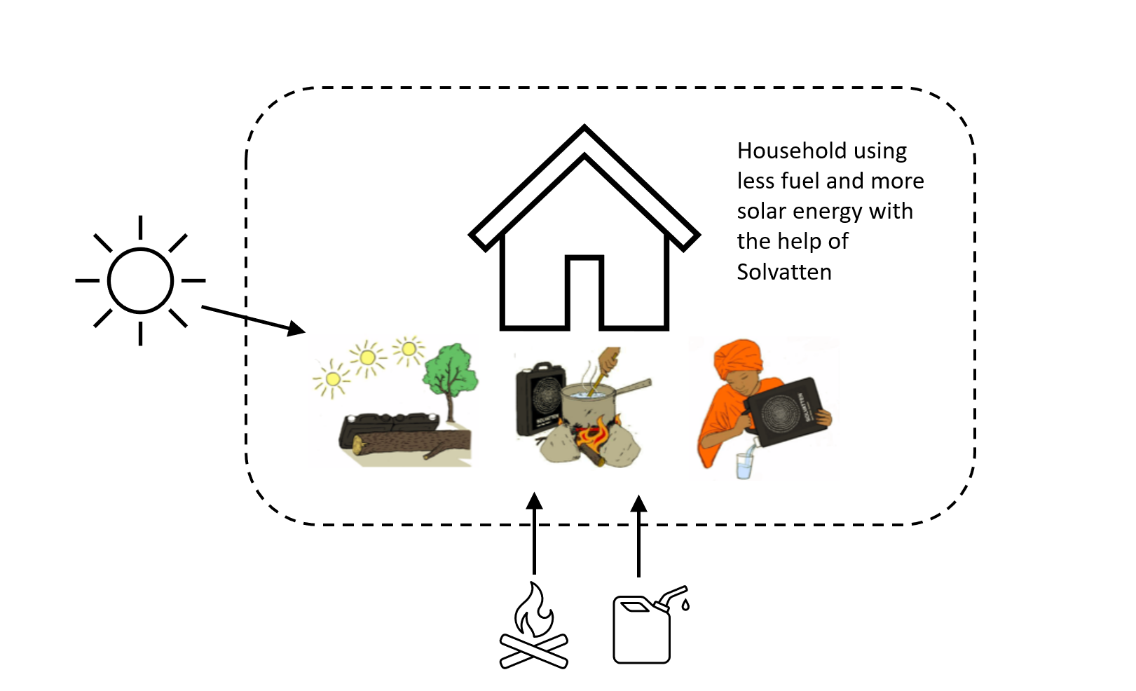

B.4. Establishment and description of baseline scenario
The baseline for calculation emissions reductions is defined according to the selected methodology (ERSDWS v1.0), by defining the baseline situation for “Pre-project practices of boiling water, or drinking unsafe water (suppressed demand)”, “Efficiency of water boiling systems” and “Baseline fuels”. Additionally, the baseline situation regarding the fraction of non-renewable biomass (f_{NRB}) is explained, and also the baselines for the additional goals that are monitored.

Baseline Survey of target population characteristics

A baseline survey of the target population characteristics was conducted in October/November 2022 (The baseline survey was first finished 18/10/2022, and then followed up with questions where some data was found missing during quality control and result calculation. The complete result with follow up was finished 08/11/2022) among a population of households selected as future users of the system (please refer to the attachment Baseline_Study_Results Solvatten 2022). The method of sampling from a pool of Future users was selected to best represent the characteristics of the typical Solvatten beneficiaries. In the exercise the survey team from Solvattens partner organisation IAS Kenya targeted four locations where Solvatten is planned to be deployed next: Gatue location, Kathangachini location, Gituma sub location and Kithigiri sub location, all within the county Tharaka Nithi. A total of 117 households were sampled to participate in the survey. In each location at least 25 prospective users were sampled, to get a diverse sample. The respondents were selected using a random number generator to choose households from the list of intended future users in each location. Intended future users are chosen according to the criteria in section A.3, by the distributing organisation, in this case IAS Kenya, often in cooperation with local government.

For Baseline Survey (BS) the minimum sample size rule from 4.2.3 of the selected methodology (ERSDWS v1.0) will be applied, and therefore a minimum sample size of 101 is used. This also satisfies the 90/10 rule as sample size does not exceed 69 for any given population size.

The questions asked and responses received, together with the compiled results, can be found in the attached “ Baseline_Study_Results Solvatten 2022”. Below the results are presented in a national context.

Pre-project practices of boiling water or drinking unsafe water
Access to clean drinking water at home is severely limited for the rural Kenyan population. The most common household water treatment nationally is boiling of water, while over 50% of the rural population uses untreated water for drinking. In the BS, 97.44% (114 hh) reports boiling to be their main way if they purify water, while 2.56% (3 hh) report having prior access to safe water without boiling, in this case all through the use of chlorine.

For users that boil unsafe water for drinking in the pre-project scenario, the general baseline scenario is that users would have boiled water for drinking in the absence of the project activity.

For the case of end-users currently drinking unsafe water because e.g., energy poverty barriers result in less than the minimum required amount of safe drinking water, the principles of suppressed demand are applied, and the baseline is set as a proxy technology (water boiling of an adequate quantity of drinking water) based on the standard of living achieved by peers (adequate supply of safe drinking water). This is implemented in practice by using the default value for drinking water demand (see parameter SDWS 24, QPW, section B.6.2) suggested in the methodology ERSDWS v1.0 for the users drinking unsafe water in the baseline scenario.

Therefore the baseline situation is that 97.44% of the population boils water from unsafe sources to make it safe for drinking, and these users are calculated to consume the default amount of drinking water demand (parameter SDWS 24, QPW, section B.6.2).

Efficiency of water boiling systems
The weighted average efficiency of the baseline water boiling systems used by the target population is determined based on:
- Default efficiencies for respective stove types specified in the ERSDWS methodology,
- Proportion of different baseline technologies used according to the BS.

In the BS the respondents were asked about both primary and secondary stove used for boiling water, and their estimated division of usage between primary/secondary type. The responses were then weighted according to this division, to give a proportion usable for calculating a weighted average efficiency that is representative for the stoves used. The weighted distribution of stove types in the BS is:
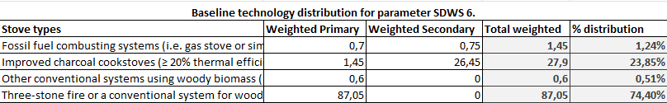
In the spreadsheet “Impact estimate” these figures are used to calculate the weighted average efficiency of the baseline water boiling systems used by the target population.
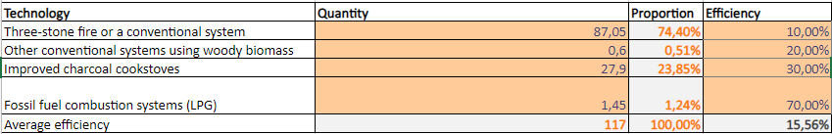

Baseline fuels
In the BS the respondents were asked about both primary and secondary fuel used for boiling water, and their estimated division of usage between primary/secondary fuel. The responses were then weighted according to this division, to give a proportion usable for calculating a representative division between used fuels. The resulting proportions from the BS was:
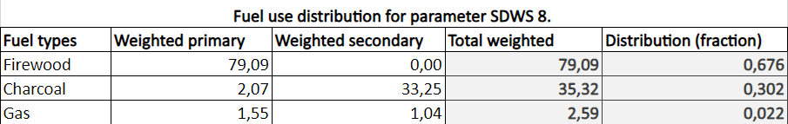

These results are cross-checked against data from the Kenya Population and Housing Census. According to the census 84% of the rural households use firewood as their main fuel, 7.7% use charcoal, 5.6% use LPG, 1.6% use paraffin, while electricity, biogas and solar are under 1% each. Compared to the BS results these are similar, while charcoal is higher and firewood lower in the BS than the Census, the fuels are in the same order of relevance. A National Cooking Sector Study commissioned by Kenya’s Ministry of energy states that three-stone fire in combination with a secondary charcoal stove is a common combination in rural areas, table 5 at pg 44, and table ES 2 pg 16. It also states that over 40% of rural households use a charcoal stove.

f_{NRB} Assessment
The tree cover in Kenya is 7.4% of the land area, and the decrease in forest cover can be attributed to the use of wood as fuel and especially the burning of wood to charcoal, according to Kenyan National Environment Management Authority, NEMA. The massive deficit in fuelwood supply has led to high rates of deforestation adverse environmental effects such as desertification, land degradation, droughts, and famine among others. The emission reductions in this project are the results of decreasing the burning of unsustainable woodfuels. Therefore, it is necessary to calculate what part of the woodfuel use is sustainable and what is unsustainable. In the methodology ERSDWS (and climate mitigation projects in general) this is referred to as the fraction of non-renewable biomass, or f_{NRB}. It is calculated according to the method TOOL30 v4.0 equation pictured below, where RB is the total renewable growth of biomass in an area, and NRB is the amount of non-renewable biomass, calculated by subtracting the RB from the total biomass consumption in the area.
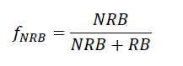

In this project, the f_{NRB} is calculated and fixed ex ante for the crediting period in the project design stage, as supported in the ERSDWS methodology. For more information on the f_{NRB} value and calculations for this specific project please refer to parameter SDWS 21 in section B.6.2 of this PDD. The methodology used to calculate the emissions reductions also uses the IPCC emission factor for fuelwood and charcoal (SDWS 9 & 10, section B.6.2). These are the emission factors for combustion of the fuelwood and the production and combustion of the charcoal. Although, this does not include emissions from decomposing root systems and other emission effects of deforestation apart from the direct use/production of the wood fuel, this estimation of emissions reductions can therefore be considered conservative.

Baseline situation for additional addressed SDG impacts
SDG 1 No Poverty
In many developing countries, biomass for cooking accounts for over 90% of household energy usage, with sub-Saharan Africa having the world’s largest share of per capita wood fuel consumption when compared to the global average per annum. This scenario is most pronounced in rural areas in developing countries because they have limited access to clean energy sources, especially for cooking. The share of poor household’s income spent on fuels forms a significant proportion of their expenditure and sometimes can overtake other essential items like schooling and health costs when local fuel prices rise.
The use of Solvatten creates significant health, educational and economic benefits to the households, and in addition to this, it also generates a substantial national drive towards renewable energy. Solvatten also effectively addresses the effects of climate change and reduces the populations’ vulnerability. The use of Solvatten reduces household expenditures. Significant energy cost savings for household when access to safe and hot water reduces the need to purchase charcoal and other fuels. Significant savings for a household as the number of sick-days and medical costs drop.

SDG 3 Good health and well-being
According to the BS over 70% of households suffer from water-borne diseases every few months, and over 20% suffer from water-borne diseases once per month or more frequently. Also according to the BS, over 70% of the households has 2-4 hospital visits per year due to water-related issues, and the mean is 3 hospital visits per household per year.

Since Solvatten can reduce the incidence of diarrhoea and other waterborne diseases among users, and especially in children, many lives can be saved. Using Solvatten keeps the poverty related diseases away. Safe and warm water and easy access to improve hygiene practices will reduce vulnerability to the major infectious diseases. It also reduces respiratory diseases and burn injuries as it reduces the need of boiling on a stove in enclosed rooms. Solvatten produces safe and hot water which improves living standards and hygiene behaviour.

SDG 5 Gender Equality
Many women in rural Kenya spend a huge amount of time on an unpaid domestic workload caring for the family and they have little time for income generating activities, according to Kenyan SDG 5 strategy, section 2.4 . According to the strategy document, women spend 5 hours of unpaid time on primary care, compared to 1 hour for men, and women and girls do 71% of the work collecting water for households. When parents in poor communities have insufficient money for school fees, they often send the boys to school, and not the girls. Girls staying out of school help caring for their siblings, collecting water, and gathering firewood in unsafe locations exposed to risk of gender-based violence. The health benefits and the time and money saved with Solvatten will provide time for income-generating activities and give more girls the opportunity to go to school. Women save many hours a day when using Solvatten.

SDG 6 Clean Water and Sanitation
According to the BS 79% of the household collect their water from unimproved sources, most commonly, at 61%, from surface water. The mean distance to the main water source is 2,5 km.
More than a billion people worldwide lack access to clean water at home, most of them living in the global south. Local governments and authorities face enormous challenges of providing all citizens with sustainable energy and safe water access at home and lack the financial means and structure to do so. Lack of potable water, poor sanitation, and dangerous hygiene practices increase vulnerability to infectious and water-borne diseases, which are direct causes of acute malnutrition. Improved hygiene and reduced malnutrition, especially among children. Safe water together with easy access to heated water improves hygiene practices. Solvatten directly tackles water and hygiene-related diseases, such as intestinal worms, and the safe heated water makes the transition from breast milk more manageable and less risky.

SDG 7 Affordable and clean energy
Limited access to energy is a major challenge. The most common types of fuel in Kenya used for cooking by households are firewood, charcoal, large consumption of biomass for energy purposes could lead to biodiversity loss and increased deforestation, desertification, and land degradation. According to the 2019 Kenya population and housing census the use of Solar energy, electricity or biogas for cooking is below 1% respectively. This project will increase the share of final energy use for cooking that comes from solar energy and decrease the amount that comes from unsustainably harvested biofuels.
Solvatten uses the synergetic effect of UV radiation and the thermal energy from the sun. For every kWh of energy from the sun that we can transform to the benefit of the poor, the bigger the benefit for the society and the planet. By letting the trees that otherwise would be used as fuel, stay standing, multiple benefits such as increased productivity, improved food supply and capture of CO2 are achieved.

SDG 15 Life on land
The UNFCCC has defined deforestation as “the indirect, human-induced conversion of forested land to non-forest land”. Kenya is currently facing deforestation partly due to the use of firewood for household energy use in the form of charcoal and firewood. With Solvatten, using the energy from the sun, trees are left to continue to grow and to store carbon and hectares of forest are saved.

B.5. Demonstration of additionality
This project demonstrates automatic additionality by fulfilling the following criteria:
Specify the methodology, activity requirement or product requirement that establishes deemed additionality for the proposed project (including the version number and the specific paragraph, if applicable). | Paragraph 4.1.9 a) in Community services activity requirements Version 1.2 states that a project covered by the positive list in Annex B of the same document is deemed additional and not required to prove financial additionality at the time of Design Certification.
Describe how the proposed project meets the criteria for deemed additionality. | The proposed project activity is composed of isolated units where the users of the technology are households or communities and where each unit results in <= 600 MWh of energy savings per year and <=600 tonnes of emission reductions per year. This type of project activity is covered by paragraph 1.1.3 of Annex B.

B.5.1 Prior Consideration
At conception the project was planned to be retroactive (I.e. the start date before the stakeholder consultation) but during the development and validation process, the start date has been shifted forward in time due to the requirement of water testing within the first 6 months.
From PAR section 4.1.40 “For distributed technology projects, the start date is the date of implementation of the first unit under the project.” For this project, the Project start date is 01/11/2022. Please refer to the attached distribution registration of the first user counted as part of the project (“Reciept_1st_user_registration20221101.pdf”). Please refer to section C.1 for more information and background on the project start date.

As this shift of project start date means the Stakeholder consultation meeting took place before project start date, this project is not a retroactive project, but a regular.

The time of first submission is within one year of the project start date.
The time of first submission is 01/12/2021, and the project start date is 01/11/2022 which is the date of the distribution of the first SOLVATTEN included in the project activity.
Timeline/Milestones:
- 01/12/2021 Time of first submission
- 21/04/2022 Preliminary review approval
- 27/10/2022 Stakeholder consultation meeting
- 01/11/2022 First unit included in the project is distributed to user (within one year of the first submission). Project start date, 1st Crediting period start date
- 27/04/2023 Time of first field water testing (less than 6 months after start date)

B.5.2 Ongoing Financial Need
The project is not subject to design certification renewal, and not required to demonstrate financial additionality, as stated above. Therefore, this section is not relevant.

B.6. Sustainable Development Goals (SDG) outcomes
Relevant Target/Indicator for each of the targeted SDGs. The impact on SDG 13 will be monitored, quantified and verified as GSVER, while SDGs 1, 3, 5, 6, 7, and 15 will be monitored and quantified as Certified SDG Contributions.
Sustainable Development Goals Targeted | Most relevant  SDG Target | SDG Impact
 |  | Indicator (Proposed or SDG Indicator)
13 Climate Action  (mandatory) | 13.2 | Emission Reductions
1 No Poverty | 1.1 | Number of households reporting reduced expenses on fuel and medical treatment
3 Good health and well being | 3.9 | Number of households reporting improved health
5 Gender Equality | 5.4 | Number of households reporting time saved on cooking and fuel collection
6 Clean Water and Sanitation | 6.1 | Total additional number of households with access to safe water supply
7 Affordable and clean energy | 7.2 | Displaced Non-Renewable Energy in MWh
15 Life on land | 15.1 | Total Weight Saved of Non-Renewable Biomass

B.6.1 Explanation of methodological choices/approaches for estimating the SDG Impact

Impact calculations for all the monitored SDGs including SDG 13 are made in the “Impact Estimate” spreadsheet. This chapter describes the calculations and reasoning behind them.

SDG 13
The calculations to assess the impact on SDG 13 follows the steps described in the selected methodology, ERSDWS v1.0, where Section 3.6 describes the Baseline emissions calculations, section 3.7 the Project emissions calculations, and 3.8 the leakage assessment.

ER_{y} Emissions Reduction
The total leakage adjusted Emissions Reduction per year (Leakage adjusted ER_{y}) is calculated by subtracting the Project Emissions (PE_{y}) and Leakage Emissions (LE_{y}) from the Baseline Emissions (BE_{y}).
Calculated as:
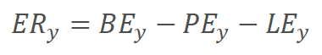

BE_{y} Baseline emissions
Baseline emissions are calculated as follows:
Equation 3 from the methodology ERSDWS, where:
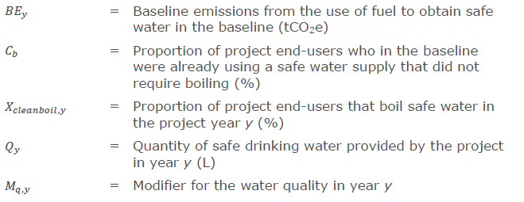
C_{b}, X_{cleanboil,y} and M_{q,y} are defined further in the parameter tables below.

Baseline emission factor
EF_{b} is the baseline emission factor, and is defined as:
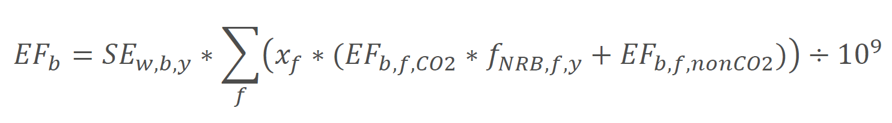
Equation 1 from the methodology ERSDWS, where:
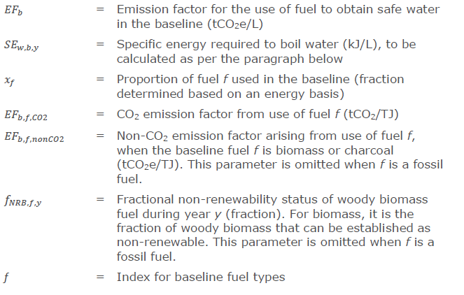 These factors are further defined in the paragraphs and parameter tables below.

Specific energy
SE_{w,b,y} is the specific energy required to boil water using the baseline technology. Defined in line with the methodology it is:
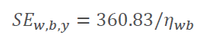
Equation 2 from the methodology ERSDWS, where 360.83 = Default amount of energy input required to obtain 1 L of boiling water, including boiling and vaporization losses, according to the methodology.

And 𝜂_{𝑤𝑏} is the average of respective default efficiencies weighted for the surveyed distribution of baseline technologies. It is further defined in the parameter tables below.

Quantity of safe drinking water provided by the project activity
According to the methodology, there is two methods available to calculate this quantity. As this project is based on a Household Water Treatment solution, the quantity of safe drinking water provided by the project 𝑄𝑦 is calculated using Method 2 for HWT technologies. Equation 6 from the methodology ERSDWS
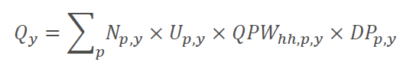
Where:
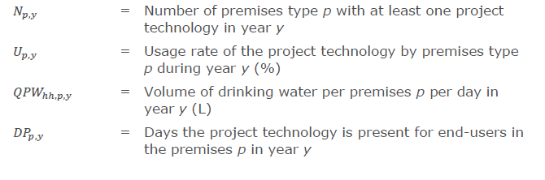
N_{p,y} , U_{p,y} , DP_{p,y} are defined in the parameter tables below.

QPW_{hh,p,y} is the volume of drinking water per premises per day is determined by
considering whether the capacity of the project device is sufficient to provide at
least the default amount of drinking water, according to equation 7 in the methodology ERSDWS, as follows:
Where:

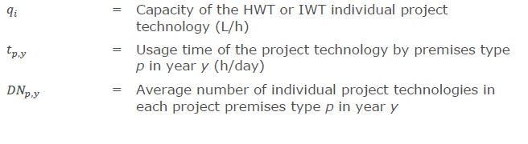
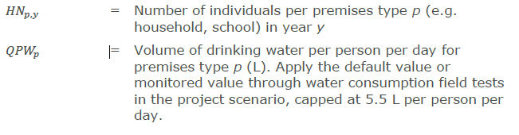
q_{i}, t_{p,y} , DN_{p,y} , QPW_{p} and HN_{p,y} are defined further in the parameter tables below.

PE_{y} Project emissions
Project emissions in year y is defined as
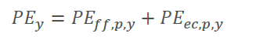
Where PE_{ff,p,y} is the Project emissions from fossil fuel use in year y and PE_{ec,p,y} is the Project emissions from electricity use in year y. As the project activity uses neither fossil fuels nor electricity (refer to section A.3 for more information about the technology), both PE_{ff,p,y} , PE_{ec,p,y} and consequently also the Project Emissions PE_{y} are 0 tCO2.

LE_{y} Leakage Emissions
To assess the leakage, the following leakage sources should be considered according to section 3.8.2.1 of the methodology.
- Members of the population who do not participate in the project, and previously used lower emitting energy sources, instead use the non-renewable biomass saved under the project activity.
Fuel wood is sourced individually by household or bought at markets where prices depend on supply/demand in a larger area. There is no indication that a household previously using a lower emission energy source would switch to using biomass as a result of this kind of intervention.

- The project significantly reduces the NRB fraction within an area where other GHG mitigation project activities account for NRB fraction in their baseline scenario.
A project at this scale will have a negligible effect on the total NRB fraction, as it is usually calculated for the entire country.
- The project population compensates for loss of the space heating effect of water boiling by adopting some other form of space heating or by retaining some baseline wood fuel-burning practices.
In the project area, Kenya, the average temperature is over 20°C, and space heating technology in rural Kenya is very rare. The end-users of the project technology will still use fire for cooking and other tasks not related to drinking water.

The leakage risks are deemed very low, and the ex-ante estimate of leakage emissions is less than 5% of the total emission reductions of the project, no additional monitoring of leakage emissions is needed according to section 3.8.3 of the ERSDWS methodology. According to the same section, the total emissions reductions shall be adjusted 5% down, and the leakage risk/emissions shall be reassessed at the time of crediting period renewal.

Leakage Emissions are estimated as 5% of the Emission Reductions prior to leakage adjustment, calculated as LEy = 0,05 x (non adjusted ERy).

Sustainable Development Goal 1
The use of SOLVATTEN helps households reduce fuel and medical expenditures. The assessment for Sustainable Development Goal (SDG) 1, which is No Poverty, uses two factors,
- Proportion Reporting Savings (PRSy). Proportion of households reporting reduced expenses because of the project activity in the Project survey.
- Total Reporting Savings (TRSy) is the estimated total number of households reporting reduced expenses based on TRSy = PRSy x N_{p,y}
Where TRSy is the number reported as the SDG 1 contribution.

Sustainable Development Goal 3
The use of SOLVATTEN improves end-user health by cleaner indoor air and safe water access. The assessment for Sustainable Development Goal (SDG) 3, which is Good Health and Well-being uses two factors,
- Proportion Reporting Improved health (PRIy). Proportion of households reporting improved health for household members because of the project activity in the Project survey.
- Total Reporting Improved health (TRIy) total number of households reporting improved health based on TRIy = PRIy x N_{p,y}
Where TRIy is the number reported as the SDG 3 contribution.

Sustainable Development Goal 5
The use of SOLVATTEN saves time on chores such as fuel collection and cooking typically performed by women, freeing up time to pursue more constructive and empowering activities. The assessment for Sustainable Development Goal (SDG) 5, which is Gender Equality, uses two factors,
- Proportion Reporting Time saved (PRTy). Proportion of households reporting time saved on fuel collection and cooking because of the project activity in the Project survey.
- Total Reporting Time saved (TRTy) total number of households reporting time saved based on TRTy = PRTy x N_{p,y}
Where TRTy is the number reported as the SDG 5 contribution.

Sustainable Development Goal 6
The contribution to Sustainable Development Goal (SDG) 6, which is Clean Water and Sanitation, is defined as the Total additional number of households with access to Safe Water supply (TSWy). This is calculated based on the total number of active units, the usage rate and subtracting the proportion of end user that already had access to clean water in the baseline TSWy = N_{p,y} x U_{p,y} x (1-C_{b}).

Sustainable Development Goal 7
The contribution to Sustainable Development Goal (SDG) 7, which is Affordable and Clean Energy, is defined as the amount of energy from non-renewable sources in the baseline that is displaced by free and renewable solar energy in the project scenario. This is expressed in MWh as Displaced Non-Renewable Energy (DNREy).

This number is calculated using the total Litres of water supplied by the project (Q_{y} in L), specific energy required to boil water with the baseline technology (SE_{w,b,y} in kJ/L), the fraction of non-renewable biomass (f_{NRB} in %), and the conversion factor (1/3 600 000) to convert from kJ to MWh.
Calculated as DNREy = Q_{y} x SE_{w,b,y} x f_{NRB} x (1/3 600 000).

Sustainable Development Goal 15
The use of SOLVATTEN reduces local demand pressure on unsustainable biomass by decreasing the total demand for firewood and charcoal. The contribution to SDG 15 is defined as the Total Weight Saved of Non-Renewable Biomass (TWS_{NRB}) in tonne.
- First, the Total Weigh Saved for the respective biofuels (TWS_{b} for wood and charcoal) is calculated using SE_{w,b,y}: the specific energy required to boil water with the baseline technology (in kJ/L), x_{f}: the fraction of the specific fuel used compared to total fuel used (%), NCV_{b}: the Net Calorific Value for respective fuel converted from TJ/kton to kJ/kg by dividing with 1000 and 𝑄𝑦: the total Litres of water supplied by the project (L).
calculated as TWSf = SE_{w,b,y} * x_{f} / (NCV_{b}/1000) * 𝑄𝑦.
- Then, Total Weight of Saved biomass (TWS_{bio}) is calculated by adding the Total Weight of Saved wood (TWS_{wood}) to the Total Weight of Saved charcoal (TWS_{charcoal}) multiplied by a Charcoal-to-Wood conversion factor (CtW).
Calculated as TWS_{bio} = TWS_{wood} + (TWS_{charcoal} x CtW).
- Lastly, to calculate the TWS_{NRB}, the TWS_{bio} is multiplied with the f_{NRB} to count only the proportion of biomass estimated to be non-renewable, then divided by 1000 to convert from kg to tonne.
Calculated as TWS_{NRB} = TWS_{bio} x f_{NRB} / 1000.

B.6.2 Data and parameters fixed ex-ante

SDG13
Parameter ID | SDWS 2
Data/parameter | Project technology description
Unit | NA
Description | - Manufacturer name:  - KB Components AB, Solvatten AB  - Product name:  - SOLVATTEN Solar Safe Water Heater  - Technology type:  - Point-of-use system for solar UV heating and disinfection of water.  - Performance target classification:  - Project technology provides water that is microbiological safe in accordance with laboratory test that meets and follows the US EPA Guide Standard for Water Purifiers, equivalent to WHO guidelines for safe drinking water under section "Highly Protective Technology”.  For more detailed information and references please see section A.3 of this PDD.
Source of data | Project developer, product specification, manufacturer documentation
Value applied | NA
Choice of data or Measurement methods and procedures | NA
Purpose of data | Ensure project technology compliance with requirements in P&R and methodology
QA QC Procedures | Project developer is also the inventor and owner of the project technology, ensuring good insight in the project specifications. The patented product is made in Sweden, at an ISO 9001-certified manufacturer that has a long history of successful cooperation with Solvatten. The manufacturer is certified by DNV to follow ISO 9001:2015, ISO 16949:2016, ISO 14001:2015 and ISO 45001:2018
Additional comment | NA

Parameter ID | SDWS 4
Data/parameter | Regulatory framework for safe water supply
Unit
Description | List and provide a summary of any national, sub-national and local regulations or guidance for safe drinking water supply, operation and maintenance, including any tariff requirements. Describe how the project complies with the regulatory framework.
Source of data | National, sub-national and local authorities
Value applied | This is covered under “Regulatory framework” after the eligibility criteria table in section A.1.1 of this PDD
Choice of data or Measurement methods and procedures | Review of national, regional and local regulations, and having the subject on the agenda with partner organisations, stakeholder meetings.
Purpose of data | To assess project compliance with any national, sub-national and local regulations or guidance for safe drinking water supply, operation and maintenance, including any tariff requirements.
QA QC Procedures | The regulatory framework is compiled after thorough review, based on the project developers vast experience in the host country and longstanding cooperation with local government and non-government actors.
Additional comment | Update at the start of each crediting period. Review to make sure the project will not undermine or conflict with any national, subnational and local regulations or guidance for safe drinking water supply, operation and maintenance, including any tariff requirements.

Parameter ID | SDWS 5
Data/parameter | Water sources in the project boundary
Unit
Description | Identify the water sources in the project boundary, and identify whether they are used for drinking water, and for all that are used for drinking water, classify them as improved and unimproved water source. Please refer to tab “Main Water Source” in the excel summary of the baseline survey.
Source of data | Baseline Survey
Value applied | 21% improved  79% unimproved
Choice of data or Measurement methods and procedures | Cross checked against Table 2.15 pg 300 in Kenya Population and Housing Census volume IV
Purpose of data | Baseline scenario description
QA QC Procedures | Cross checked against Table 2.15 pg 300 in Kenya Population and Housing Census volume IV as mentioned above.
Additional comment | Undertake at the start of each crediting period and at the time of project design change approval where the project boundary is being revised/expanded to new areas.

Parameter ID | SDWS 6
Data/parameter | Stove technologies used in the project boundary
Unit | %
Description | The proportion of different stove types used in premises in the geographical area of the project.
Source of data | Baseline Study
Value applied | Three-stone fire or conventional system: 74.40%  Other conventional syst. using woody biomass: 0.51%  Improved Charcoal stoves: 23.85%  Fossil fuel combusting systems (LPG): 1.24%
Choice of data or Measurement methods and procedures | Sourced from Baseline Survey to get a value specific to the project boundary
Purpose of data | Estimating baseline technology efficiency (SDWS 11) to be used in equation 2 of the methodology to determine the specific energy needed to boil water in the baseline.
QA QC Procedures | Cross checking against national data in the baseline description of this PDD.
Additional comment | Baseline technology use preference is a factor when selecting the households to target in this project. Therefore, the characteristics of this parameter are expected to be more homogenous within the target group of users than within certain geographical clusters. Because of this, surveying the proportions of stove types in different geographical locations is not deemed to be relevant. As the project grows and expands to new locations, the variance between regions will be monitored and this methodology be revised if the locations vary more than expected.

Parameter ID | SDWS 7
Data/parameter | Expected technical life of project technology
Unit | years
Description | The expected technical life of an individual project technology is defined based on Product specification.
Source of data | Manufacturer specifications
Value applied | 7
Choice of data or Measurement methods and procedures | The expected technical lifetime of the project technology is at least 7 years. This is a conservative estimate, and units are automatically retired after 7 years in the project database even if they are still functional. Most units will continue to function beyond this estimate and produce emissions reductions which are not accounted for in this project. Units that cease to be functional before the estimated lifetime expires will be discounted by the Usage Rate Survey.
Purpose of data | Determining the number of active units
QA QC Procedures | Please see “Choice of data or Measurement methods and procedures”
Additional comment | Emission reduction claims are limited to the expected technical life, units are marked as retired in the project database after the technical lifetime.

Parameter ID | SDWS 8
Data/parameter | x_{f}
Unit | %
Description | Percentage of fuel f use in target population. The proportion of each different cooking fuel f used in the project boundary by end-users:  - if single fuel is used for water boiling:  % Among the target population.  - if multifuel situation exists within premise:  Weighted average on energy basis.
Source of data | Baseline Study
Value applied | Wood 67.6%  Charcoal 30.2%  Fossil 2.2%
Choice of data or Measurement methods and procedures | Sourced from Baseline survey to get a value specific to the project boundary. Cross-checked against Table 2.18 pg 330 in Kenya Population and Housing Census volume IV  The fuel use percentage is weighted based on use frequency basis.
Purpose of data | Determining baseline scenario, Monitoring of project contribution to SDG 15
QA QC Procedures | Please see “Choice of data or Measurement methods and procedures”
Additional comment

Parameter ID | SDWS 9
Data/parameter | EF_{b,f,CO2}
Unit | tCO₂/TJ
Description | CO₂ emission factor from use of fuels
Source of data | IPCC defaults. For wood and charcoal, the following defaults derived from the IPCC is applied:
Value applied | Wood: 112 tCO₂/TJ  Charcoal: 165.22 tCO₂/TJ  Fossil: 63.1 t CO₂/TJ
Choice of data or Measurement methods and procedures | Wood and charcoal based on values from the selected methodology ERSDWS v1.0.  For fossil, the default factor for LPG from table 2.5 chapter 2 of “2006 IPCC Guidelines for National Greenhouse Gas Inventories” is used.
Purpose of data
QA QC Procedures | Using standardised values from either the methodology or reliable sources like the IPCC ensures the quality of this parameter.
Additional comment

Parameter ID | SDWS 10
Data/parameter | EF_{b,f,nonCO2}
Unit | tCO₂e/TJ
Description | Non-CO₂ emission factor from use of fuels, in case the baseline fuel is biomass or charcoal
Source of data | For wood, charcoal and LPG, the following defaults derived from the IPCC AR5 GWP is applied.  The Methane and Nitrous Oxide emissions for LPG are from the “2006 IPCC Guidelines for National Greenhouse Gas Inventories”
Value applied | - Wood: 9.46 tCO₂e/TJ  - Charcoal: 44.83 tCO₂e/TJ (includes production emissions of CH₄ and N₂O)  - LPG: 0.167 tCO₂e/TJ
Choice of data or Measurement methods and procedures | Based on the selected methodology ERSDWS v1.0
Purpose of data
QA QC Procedures | Using standardised values from the methodology ensures the quality of this parameter.
Additional comment

Parameter ID | SDWS 11
Data/parameter | η_{wb}
Unit | %
Description | Weighted average efficiency of the baseline water boiling devices. Calculated using the proportion of different stove types used and the default stove efficiencies.  The following default efficiencies are used based on the selected methodology ERSDWS v1.0:  - Three-stone fire or a conventional system for woody biomass lacking improved combustion air supply mechanism and flue gas ventilation system, that is without either a grate or a chimney: default efficiency 10%.  - Other conventional systems using woody biomass: default efficiency 20%.  - Improved cookstoves: manufacturer specification, or if not available, default efficiency 30%.  - Fossil fuel combustion systems: 70% efficiency used. To be conservative, the maximum efficiency found for domestic LPG stoves, is used here.
Source of data | Default values for efficiency from selected methodology. Technology distribution from SDWS 6. Calculated in “Impact Estimate.xlsx”
Value applied | 15.56%
Choice of data or Measurement methods and procedures | Default values from selected methodology
Purpose of data
QA QC Procedures | Using standardised values from the methodology together with data from a baseline survey conducted according to methodology requirements ensures the quality of this parameter.
Additional comment

Parameter ID | SDWS 12
Data/parameter | C_{b}
Unit | %
Description | Proportion of project end-users who in the baseline were already using safe water from a water treatment method other than boiling.
Source of data | Baseline survey
Value applied | 2.56%
Choice of data or Measurement methods and procedures | As the suggested baseline scenario in the selected methodology ERSDWS v1.0: For household end-users currently drinking unsafe water, the principles of  suppressed demand are applied, such that the general baseline scenario is assumed to be that users would have boiled water for drinking in the absence of the project activity. Therefore, 𝐶_{𝑏} is defined as the Proportion of project end-users who in the baseline were already using safe water from a water treatment method other than boiling. Sourced from Baseline survey to get a value specific to the project boundary.
Purpose of data | Determining baseline scenario, Monitoring of project contribution to SDG 6
QA QC Procedures | Updates at the start of each crediting period. Cross checked against water access for rural households in table 2.15 pg 300 in Kenya Population and Housing Census volume IV from 2019, but as the project specifically targets areas and end-users with low prior access to safe water, the values are expected to vary and be lower in this projects baseline than in the sources.  According to the principles of Suppressed Demand, this factor does not discount for, or disqualify, users who did not boil water in the baseline due to demand suppression (for example can’t afford fuel). These users are also counted as if they were boiling in the baseline.
Additional comment

Parameter ID | SDWS 13
Data/parameter | q_{i}
Unit | Litres / hour
Description | Capacity of the household or institutional water treatment technology
Source of data | Manufacturer Specifications
Value applied | 5
Choice of data or Measurement methods and procedures | The capacity is 5 L/h. This is derived from the batch volume of 10 L/batch divided by time per batch, 2 h/batch.
Purpose of data | Determining baseline and project emissions
QA QC Procedures | Project developer is also the inventor and owner of the project technology, ensuring good insight in the project specifications. Capacity based on vast experience of projects with the same technology.
Additional comment

Parameter ID | SDWS 21
Data/parameter | f_{NRB}
Unit | %
Description | Fractional non-renewability status of woody biomass fuel. Fixed ex-ante for the crediting period
Source of data | TOOL30 v4.0  See calculations submitted with PDD
Value applied | 78.14
Choice of data or Measurement methods and procedures | As the area of forest cover in Kenya is decreasing while the population and demand is increasing, and the used value is lower than previously used defaults, the used value can be assumed to be a conservative estimate.
Purpose of data | Determining baseline and project emissions, Monitoring of project contribution to SDG 15 and SDG 7
QA QC Procedures | Calculated according to the latest version of the recommended method TOOL30 v4.0, resulting in a lower figure than the old, standardised numbers.
Additional comment

Parameter ID | SDWS 24
Data/parameter | QPW
Unit | Litres/person/ day
Description | Volume of drinking water per person per day for an end-user household
Source of data | Default value from methodology is used
Value applied | 4
Choice of data or Measurement methods and procedures | Default value from methodology
Monitoring frequency | Default, but review every two years
QA/QC Procedures | Using the default value from the methodology, but continually reviewing the applicability of this default ensures quality.
Purpose of data
Additional comment | Cap is determined based on WHO recommendations (Domestic Water Quantity, Service Level and Health, Table 2: Volumes of water required for hydration, WHO 2003).  By applying this default value for of drinking water demand, Supressed demand is taken into account as this value is applied to all households not having previous access to clean water, even if they previously did not always boil water due to demand suppression (for example price constraints).

Parameter ID | SDWS 30
Data/parameter | T_{p,y}
Unit | Hours per day
Description | Usage time of the project technology year y.
Source of data | Methodology ERSDWS v1.0, SDWS 30 option 3: Default of 5 hours.
Value applied | 5
Choice of data or Measurement methods and procedures | Default from methodology
Monitoring frequency | Default, but review value annually
QA/QC Procedures | Using the default value from the methodology, but continually reviewing the applicability of this default ensures quality.
Purpose of data
Additional comment

SDG 15
Parameter ID | NCV_{b}
Data/parameter | NCV_{b}
Unit | TJ/Gg
Description | Net calorific value of the biomass fuel used in the baseline scenarios
Source of data | Default values from IPCC.
Value applied | Wood: 15.6  Charcoal: 29.5
Choice of data or Measurement methods and procedures
QA /QC Procedures | Using the default value from the IPCC ensures quality.
Purpose of data | Monitoring of project contribution to SDG 15
Additional comment

Parameter ID | CtW
Data/parameter | CtW
Unit | proportion
Description | Charcoal to Wood conversion factor, Weight unit of wood per weight unit of charcoal
Source of data | From the UNFCCC TOOL30 v4.0
Value applied | 6
Choice of data or Measurement methods and procedures | Standard value
QA/QC Procedure | Using a standard value from the recommended method TPOOL30 ensures quality.
Purpose of data | Monitoring of project contribution to SDG 15
Additional comment | Default wood to charcoal conversion factor of kg firewood (wet basis) per kg of charcoal (dry basis)

B.6.3 Ex ante estimation of SDG Impact
As a sample for the year 1 estimates, the equations are calculated as:
Please observe the equations written here won’t be equal to the decimal if calculated as they are written; there is rounding here not made in the spreadsheet. For the exact values, please refer to calculations in the “Impact Estimate” spreadsheet submitted together with this PDD. For more information about the calculations in plain text, please refer to section B.6.1.

SDG 13

For SDG 13, the impact is calculated as:


Where the unit of impact is tonCO2e

Where:
Units:
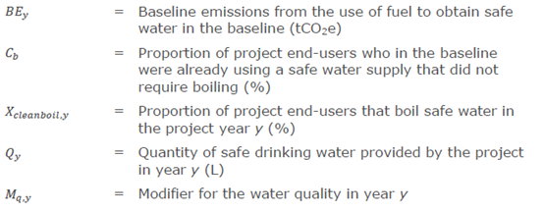
Sample calculation for Y1:
BE_{y} = 4472.274 = 0.000277 *(1-0.0256-0.01)*16744320*1

Where:

Units:
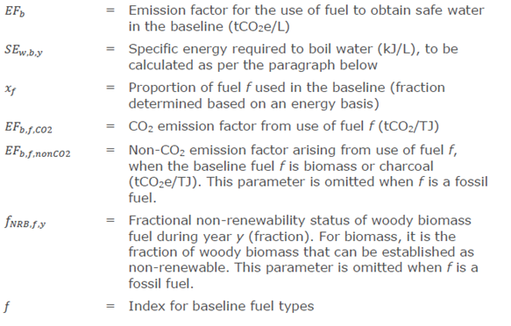
Sample calculation for Y1:
EF_{b} = 0.000277 = 2318.155 *(
(0.676*(112*0.7814+9.46))
+(0.302*(165.22*0.7814+44.83))
+(0.022*(63.1+0.167))
) /10⁹

And

The unit for SE_{w,b,y} is kJ/L, the number 360.83 is also in kj/L, while the efficiency η is in %.
SE_{w,b,y} = 2318.155 = 360.83 / 0.1556

And
Units:
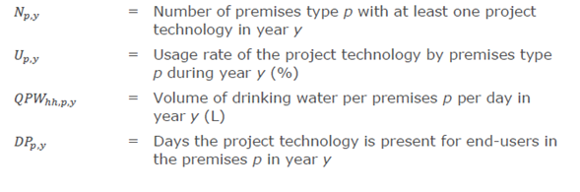
Sample calculation for Y1:
Q_{y} = 16744320 = (5400*0.85*20*182.4)

Where:
Units:
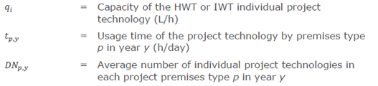
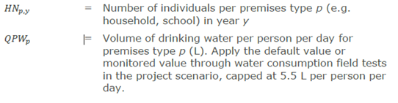
Sample calculation for Y1:
QPW_{hh,p,y} = 20 = min { (5*5*1) , (5*4) }

And where:

The units for project emission are in tonCO2e
PE_{y} = 0 = 0 + 0

SDG 1
Calculated as:
TRSy = PRSy x N_{p,y}
Units are Number of households for TRSy, proportion for PRSy and Number of households for N_{p,y}. Sample calculation for Y1:
4050 = 0.75 * 5400

SDG 3
Calculated as:
TRIy = PRIy x N_{p,y}
Units are Number of households for TRIy, proportion for PRIy and Number of households for N_{p,y}. Sample calculation for Y1:
4050 = 0.75 * 5400

SDG 5
Calculated as:
TRTy = PRTy x N_{p,y}
Units are Number of households for TRTy, proportion for PRTy and Number of households for N_{p,y}. Sample calculation for Y1:
4050 = 0.75 * 5400

SDG 6
Calculated as:
TSWy = N_{p,y} x U_{p,y} x (1-C_{b})
Units are Numper of households for TSWy and N_{p,y}, while U_{p,y} and C_{b} are proportions.
4472.496 = 5400 * 0.85 * (1-0.0256)

SDG 7
Calculated as:
DNREy = Q_{y} x SE_{w,b,y} x f_{NRB} x (1/3 600 000)
Units are MWh for DNREy, litres for Q_{y}, kJ/L for SE_{w,b,y}, while f_{NRB} is a proportion
8425.711 = 16 744 320 * 2318.155 * 0.7814 * (1/3 600 000)

SDG 15
Calculated as:
Units are: All TWS for NRB, Bio, Wood, Charcoal are in ton, f_{NRB} is a proportion, CtW is a unitless conversion factor, SE_{w,b,y} is in kJ/L, x_{wood} and x_{charcoal} are proportions, while NCV for wood and charcoal is in TJ/kton
TWS_{NRB} = TWS_{bio} x f_{NRB} / 1000
3176.933 = 4 065 452.978 * 0.7814 /1000

Where:
TWS_{bio} = TWS_{wood} + (TWS_{charcoal} x CtW).
4 065 452.978 = 1 682 023.494 + (397 238.247 * 6)

Total Weight Saved for wood:
TWSwood = SE_{w,b,y} * x_{wood} / (NCV_{wood}/1000) * 𝑄𝑦
1 682 023.494 = 2318.155 * 0.676 /(15.6/1000) * 16 744 320

And Total Weight Saved for charcoal:
TWSf = SE_{w,b,y} * x_{charcoal} / (NCV_{charcoal}/1000) * 𝑄𝑦
397 238.247 = 2318.155 * 0.302 /(29.5/1000) * 16 744 320

B.6.4 Summary of ex ante estimates of each SDG Impact

SDG 13
Source is “Impact Estimate v3.xlsx”. Baseline estimate and Net benefit presented in this table is without the 5% leakage adjustment as requested by VVB.
Year | Baseline estimate | Project estimate | Net benefit | Unit
Year 1  01/11/2022- 31/10/2023 | 4 472 | 0 | 4 472 | tCO2e
Year 2  01/11/2023- 31/10/2024 | 13 830 | 0 | 13 830 | tCO2e
Year 3  01/11/2024- 31/10/2025 | 24 100 | 0 | 24 100 | tCO2e
Year 4  01/11/2025- 31/10/2026 | 35 446 | 0 | 35 446 | tCO2e
Year 5  01/11/2026- 31/10/2027 | 47 952 | 0 | 47 952 | tCO2e
Total | 125 800 | 0 | 125 800 | tCO2e
Total number of crediting years | 5
Annual average over the crediting period | 25 160 | 0 | 25 160 |  | tCO2e

Contributions to SDGs 1, 3, 5, 6, 7, 15
Please refer to section B.6.3 above for sample calculations for year 1. For full calculations please refer to the Impact Estimate spreadsheet.
SDG | Description | Year 1 | Year 2 | Year 3 | Year 4 | Year 5 | Average per year | Unit
SDG 1 | Number of households reporting savings | 4 050 | 8 475 | 13 350 | 18 750 | 24 675 | 13 860 | Households
SDG 3 | Number of households reporting improved health | 4 050 | 8 475 | 13 350 | 18 750 | 24 675 | 13 860 | Households
SDG 5 | Number of households reporting time saved | 4 050 | 8 475 | 13 350 | 18 750 | 24 675 | 13 860 | Households
SDG 6 | Number of additional households with safe water | 4 472 | 9 359 | 14 742 | 20 706 | 27 249 | 15 305 | Households
SDG 7 | Displaced non-renewable energy in MWh | 8 425 | 26 057 | 45 405 | 66 781 | 90 342 | 47 402 | MWh
SDG15 | Weight saved of non-renewable biomass in ton | 3 176 | 9 824 | 17 120 | 25 180 | 34 063 | 89 365 | ton

B.7. Monitoring plan
B.7.1 Data and parameters to be monitored
SDG 13
Parameter ID | SDWS 18
Data/parameter | M_{q,y}
Unit | fraction
Description | Ongoing water quality indicated as the fraction of the sampled units that supply water that passes microbial quality standard requirements for drinking water of the host country. In case a national standard is not available, the water quality shall comply with WHO Guideline values for verification of microbial quality i.e., all water directly intended for drinking must not have detectable E.Coli in any 100 ml sample i.e., less than 1 Colony Forming Unit (CFU) of E.Coli /100 ml.
Source of data | Testing of water all appliances or at a representative sample of end users at the following point where the water reaches the end-user premises: HWT and IWT: testing of the water that exits the treatment technology.  A minimum sample size of 30 must be selected.
Value applied | 1.0 (Estimate based on latest testing)
Choice of data or Measurement methods and procedures | Testing of water all appliances or at a representative sample of end users at the following point where the water reaches the end-user premises:  HWT and IWT: testing of the water that exits the treatment technology.  Every SOLVATTEN unit contains Solvatten’s patented SVI-10 Indicator that indicates and states when water is microbiologically safe in accordance with laboratory test that meets and follows the US EPA Guide Standard for Water Purifiers, equivalent to WHO guidelines for safe drinking water under section "Highly Protective Technology”. Please refer to section A.3 for more in depth information on the indicator and the extensive testing performed.  The sampling results shall satisfy at minimum the 90/10 rule, i.e. the endpoints of the 90% confidence interval lie within +/- 10% of the estimated proportion in relative units.  As the estimated proportion (based on previous experience and similar projects) is 90%, the sample size needed to satisfy the 90/10 criteria is 25. Therefore, the minimum sample size of 30 will be used.  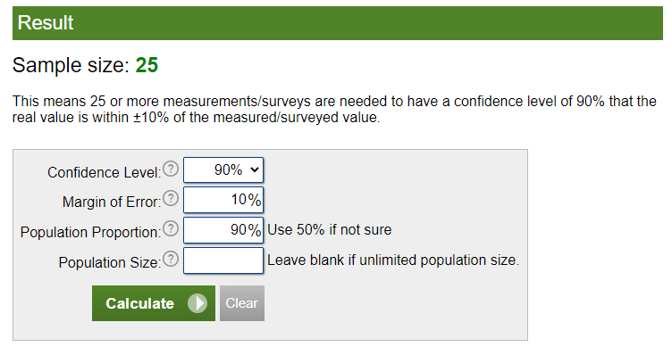Source
Monitoring frequency | Annual
QA/QC Procedures | 3. Field testing kits also are eligible, e.g. based on Colony Forming Unit method or Most Probable Number method. To use the field testing kits the project shall meet the following requirements:  a. Testing kits must be approved by national agency or meet standards set by relevant international organisation e.g. US-EPA, and  b. Testing kits shall be tested for its accuracy and robustness prior to application for project level monitoring, whereby local or accredited laboratory shall conduct water quality tests using testing kits and a relevant ISO standard or an equivalent standard, in parallel with field testing kits.  Compliance with these requirements is explained in the monitoring plan section B.7.3.
Purpose of data | Calculation of project scenario
Additional comment | If the proportion of samples not meeting Safe Drinking Water Quality Standards exceeds a threshold, no emission reductions can be claimed for the corresponding monitoring period. Thresholds:  - Project or VPA year 1: 20%  - Project or VPA year 2: 15%  - Project or VPA year 3 or above: 10%  When the crediting period is renewed, the year number count continues, i.e. the second crediting period would encompass year 6, year 7, year 8, etc. Additionally, when the threshold is exceeded, the project shall provide an explanation for why this occurred and provide a remediation plan.

Parameter ID | SDWS 19
Data/parameter | SDG Claims
Unit | NA
Description | SDG Contributions measured for SDGs 1, 3, 5, 6, 7, 15. Please refer to Parameters listed under each SDG headline below for the respective SDG, to section B.6.1 of this PDD for a full description of the estimates SDGs and to B.6.3 for sample equations.
Source of data | Project survey, Baseline survey, Default values
Value applied | Pease refer to the parameter tabled below for all SDGs
Choice of data or Measurement methods and procedures | Evaluated in Project survey
Monitoring frequency | Annual
QA/QC Procedures | Sampling and surveying according to PS sampling plan
Purpose of data | Evaluate contribution to SDGs other than 13.
Additional comment

Parameter ID | SDWS 20
Data/parameter | Water hygiene education campaigns
Unit | NA
Description | Hygiene campaigns will be carried out among project safe water end-users.  As required by the methodology, the Hygiene survey (HS) covers all the Joint Monitoring Programme (JMP) core questions for drinking water and core questions for hygiene. Beyond these requirements, the education also highlights the value of access to safe and heated water for hygiene and domestic use.  Results from the HS and the resulting fraction of households where safe water and hygiene  practices are found to fulfil “safely managed” or “basic”  requirements are reported annually.
Source of data | Report of annual hygiene campaigns results based on HS
Value applied
Choice of data or Measurement methods and procedures | Data compiled in Report of annual hygiene campaigns results. Hygiene Survey will be done in conjunction with the Project survey to get a value specific to the project boundary.
Monitoring frequency | Annual
QA/QC Procedures | The fraction of the households where Safe water and Hygiene practices are found to fulfil “safely managed” or “basic” requirements is expected to increase over time as a result of the hygiene campaigns.
Purpose of data
Additional comment

Parameter ID | SDWS 22
Data/parameter | X_{cleanboil,y}
Unit | %
Description | Proportion of project end-users that boil safe (treated, or from safe supply) water after installation of project technology in year y
Source of data | Project Survey
Value applied | 1 (estimate)
Choice of data or Measurement methods and procedures | Sourced from Project survey to get a value specific to the project boundary.
Monitoring frequency | Annually
QA/QC Procedures | This survey may be performed in person, by telephone, by messaging (e.g. text, app), appropriate to the context. For sampling, follow the section 4.2 - General requirements for sampling
Purpose of data | Calculation of BEy (equation 3)
Additional comment

Parameter ID | SDWS 25
Data/parameter | HN_{y}
Unit | Number
Description | Number of individuals per household in the project  boundary in year y
Source of data | Project Survey
Value applied | Estimate: 5
Choice of data or Measurement methods and procedures | Sourced from Project survey to get a value specific to the project boundary.
Monitoring frequency | Annual
QA/QC Procedures | Cross checked against Kenya Population and Housing  Census. Source for cross-check must not be more than 5 years old. Target population is rural, and excludes smaller households, therefore the value is expected to be higher than national rural average.
Purpose of data
Additional comment

Parameter ID | SDWS 28
Data/parameter | N_{p,y}
Unit | Number
Description | Accumulated number of households with at least one individual project technology in year y
Source of data | Project database
Value applied | For Estimates, refer to “Impact Estimate” submitted together with this PDD
Choice of data or Measurement methods and procedures | The project database is the most accurate source for this data.
Monitoring frequency | Updated continuously as units are distributed and registered in the database. Database is then monitored annually.
QA/QC Procedures | Number of units is cross checked with the numbers used to determine D_{p,y}. Each unit has a unique ID and is registered in the project database. Units are automatically marked as retired in the project database at the expiry of their technical lifetime.
Purpose of data | Calculating the quantity of safe drinking water provided by the project 𝑄y (equation 6), for estimating Bey (SDG13)and contributions to SDGs 1, 3, 5 and 6
Additional comment

Parameter ID | SDWS 29
Data/parameter | U_{p,y}
Unit | %
Description | Usage rate of the project technology during year y. The Usage Rate Survey provides a single usage parameter that is representative for project technologies in the total Project database.
Source of data | Usage Rate Survey according to the guidelines in annex 1 of the ERSDWS methodology. The methodology provides two options, in-person or by telephone. As far as possible, the in-person interview format will be used. For special circumstances, such as the sampled household is very remote, the phone interview may be used. In the cases telephone survey is conducted, the resulting fraction from those surveys will be multiplied by 75% according to the methodology.
Value applied | Estimate, 85%
Choice of data or Measurement methods and procedures | The Usage Rate Survey will cover all topics outlined in Annex 1 of the ERSDWS. Households that show at least once per week, and use the system as intended by the producer will be counted as users. Using the system as intended includes only using water when the built-in indicator indicates that the water is safe.  Further information about the built-in water quality indicator, refer to parameter SDWS 18 and section A.3 of this PDD.
Monitoring frequency | Annual
QA/QC procedures | If a future WCFT is preformed, it will be cross checked against this value. The minimum sample size for HWT - for individual technology age group will be minimum 30 households.
Purpose of data | Calculation of project scenario (Bey in equation 3), Monitoring of project contribution to SDG 6
Additional comment | The usage survey provides a single usage parameter that is representative for project technologies in the total Project database.  Applies to all HWT and IWT technologies and projects.

Parameter ID | SDWS 31
Data/parameter | DP_{y}
Unit | Days
Description | Average days the project technology is present for end-users in year y
Source of data | Project database.
Value applied | Updated continuously as units are distributed and registered in the database. Database is then monitored annually.
Choice of data or Measurement methods and procedures | Based on the sales or distribution records of “Date of  sale/distribution” and ex-ante parameter “Expected technical life of project technology”. For each project device the number of days of the 365 days of the year it was in the premises and within its technical life is calculated. The average for all the devices is calculated to obtain this parameter. Please refer to “Impact Estimate” spreadsheet, sheet “DPy & Ny” for calculations based on input from project database. In sheet “DPy & Ny” the project developer will enter the amount of units distributed every given month of the year, and the spreadsheet calculates the DP_{y}.
Monitoring frequency | Annual
QA/QC Procedures | The sum of units distributed over time is always cross checked against total number of active devices and retired devices.
Purpose of data | Calculating Qy in equation 6. Used in equation 3 for SDG 13
Additional comment

Parameter ID | SDWS 32
Data/parameter | DN_{p,y}
Unit | Number
Description | Average number of individual project technologies in year y
Source of data | Project database
Value applied | 1
Choice of data or Measurement methods and procedures | Every project end-user is a household, and every end-user household gets exactly 1 Solvatten unit.
Monitoring frequency | Annually
QA/QC Procedures | End-user details documented in project database
Purpose of data
Additional comment

Parameter ID | SDWS 35
Data/parameter | LE_{y}
Unit | tCO₂ per year
Description | Leakage emissions during year y
Source of data | Leakage assessment
Value applied | 5% of the total emission reductions
Choice of data or Measurement methods and procedures | The leakage risks are deemed very low, and the ex-ante estimate of leakage emissions is less than 5% of the total emission reductions of the project, no additional monitoring of leakage emissions is needed according to section 3.8.3 of the ERSDWS methodology. According to the same section, the total emissions reductions shall be adjusted 5% down, and the leakage risk/emissions shall be reassessed at the time of crediting period renewal.
Monitoring frequency | Updated annual as it depends on total emission reductions for the given year. Leakage risk/emissions shall be reassessed at the time of crediting period renewal.
QA/QC Procedures | Compliance with the general requirements for sampling and general requirements for data and information sources.
Purpose of data
Additional comment

SDG 1
Parameter ID | PRSy
Data/parameter | PRS_{y}
Unit | %
Description | Proportion Reporting Savings (PRSy). Proportion of households reporting reduced expenses because of the project activity in the Project survey. Multiplied with number of total end-users N_{p,y} to get the total number of households reporting reduced expenses
Source of data | Project Survey
Value applied | Estimate 75%
Choice of data or Measurement methods and procedures | Sourced from Project survey to get a value specific to the project boundary.
Monitoring frequency | Annual
QA/QC Procedures | Sampling according to validated monitoring plan
Purpose of data | This proportion is multiplied with the total number of Households (N_{p,y}) and this result is reported as project contribution to SDG 1
Additional comment

SDG 3
Parameter ID | PRIy
Data/parameter | PRI_{y}
Unit | %
Description | Proportion Reporting Improved health (PRIy). Proportion of households reporting improved health for household members because of the project activity in the Project survey. Multiplied with number of total end-users N_{p,y} to get the total number of households reporting improved health for household members.
Source of data | Project Survey
Value applied | Estimate 75%
Choice of data or Measurement methods and procedures | Sourced from Project survey to get a value specific to the project boundary.
Monitoring frequency | Annual
QA/QC Procedures | Sampling according to validated monitoring plan
Purpose of data | This proportion is multiplied with the total number of Households (N_{p,y}) and this result is reported as project contribution to SDG 3
Additional comment

SDG 5
Parameter ID | PRTy
Data/parameter | PRT_{y}
Unit | %
Description | Proportion Reporting Time saved (PRT_{y}). Proportion of households reporting time saved on fuel collection and cooking because of the project activity in the Project survey. Multiplied with number of total end-users N_{p,y} to get the total number of households reporting time saved on fuel collection and cooking.
Source of data | Project Survey
Value applied | Estimate 75%
Choice of data or Measurement methods and procedures | Sourced from Project survey to get a value specific to the project boundary.
Monitoring frequency | Annual
QA/QC Procedures | Sampling according to validated monitoring plan
Purpose of data | This proportion is multiplied with the total number of Households (N_{p,y}) and this result is reported as project contribution to SDG 5
Additional comment

SDG 6
Parameter ID | TSWy
Data/parameter | TSWy
Unit | number
Description | The contribution to Sustainable Development Goal (SDG) 6, which is Clean Water and Sanitation, is defined as the Total additional number of households with access to Safe Water supply
Source of data | Project Survey
Value applied
Choice of data or Measurement methods and procedures | This is calculated based on the total number of active units, the usage rate and subtracting the proportion of end user that already had access to clean water in the baseline TSWy = N_{p,y} x U_{p,y} x (1-C_{b}). Please refer to SDG 6 under section B.6.1 for more information.
Monitoring frequency | Annual
QA/QC Procedures | Sampling according to validated monitoring plan
Purpose of data | This number is reported as project contribution to SDG 6
Additional comment
SDG 7
Parameter ID | DNREy
Data/parameter | DNREy
Unit | MWh
Description | The contribution to Sustainable Development Goal (SDG) 7, which is Affordable and Clean Energy, is defined as the amount of energy from non-renewable sources in the baseline that is displaced by free and renewable solar energy in the project scenario. Please refer to SDG 7 under section B.6.1 for more information.
Source of data | Project Survey
Value applied
Choice of data or Measurement methods and procedures | Sourced from Project survey to get a value specific to the project boundary.
Monitoring frequency | Annual
QA/QC Procedures | Sampling according to validated monitoring plan
Purpose of data | This number is reported as project contribution to SDG 7
Additional comment

SDG 15
Parameter ID | TWS_{NRB}
Data/parameter | TWS_{NRB}
Unit | tonne
Description | The contribution to SDG 15 is defined as the Total Weight Saved of Non-Renewable Biomass. Please refer to SDG 15 under section B.6.1 for more information.
Source of data | Project Survey
Value applied
Choice of data or Measurement methods and procedures | Calculated based on values sourced from Project survey to get a value specific to the project boundary.
Monitoring frequency | Annual
QA/QC Procedures | Sampling according to validated monitoring plan
Purpose of data | This number is reported as project contribution to SDG 15
Additional comment

B.7.2 Sampling plan
Sample size and Sampling plan

For Baseline Survey (BS), Project surveys (PS) and Usage Rate Survey (URS) the minimum sample size rule from 4.2.3 of the selected methodology (ERSDWS v1.0) will be applied, and therefore a sample size of 101 is used.
From the ERSDWS Methodology:
“When a baseline and project survey is used the following sample size guidelines should be applied, unless otherwise stated for specific parameters:
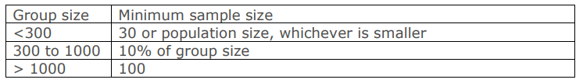“

The Hygiene Survey (HS) will be performed in conjunction with the PS. As there is no specific requirements on the sample size for the HS, it is assumed it needs to follow the general rule of minimum 100 samples. Therefore, it is reasonable to perform the HS at the households already sampled in the PS.

The guidance “Sampling and surveys for CDM project activities and programmes of activities” has been considered when developing the sampling plan, and the Simple Random Sampling approach will be used. As the Usage Rate Survey demands the samples to be taken from specific age groups as described below, the households sampled for the URS will be the households where the PS is also conducted, see description below.

Sampling method for Usage rate survey
For the Usage Rate Survey (URS) the rule from parameter “SDWS 29 Usage Rate” in the selected methodology (ERSDWS v1.0) stating that the minimum sample size per technology age group shall be minimum 30 households is applied. The term “age groups” is not defined further in the methodology. The reason to use age groups is interpreted as aiming to cluster users in a similar situation and with similar experience of using the technology, and then sample evenly from these clusters to get a representative sampling. Based on the project proponents previous experience of the usage behaviour and product performance over time, the age groups for the Solvatten technology are defined as:
- New users: from 0 up until 2 years of use
- Intermediate Users: over 2 up until 4 years of use
- Experienced users: over 4 up until 7 years of use, after which the unit is retired from the project database.
By clustering the users in these age groups, and then sampling according to the guidelines, the project proponent expects to achieve a sample that is representative for users with different levels of experience. As 30 samples from each of the three age groups will be max 90 samples, which is less than the <100 required by the methodology, the sample size for the Usage rate survey will be 100.

These samples will be distributed so that there are at least 30 from each age group, and the remaining samples will be distributed to make the sampling as proportional as possible to the distribution of users. For example, if there are 10 000 total users, with 4000 New users (40%), 3000 Intermediate users (30%) and 3000 experienced users (30%), the 100 samples will be taken first as 30 from each age group, and then the 10 remaining samples taken from the group of New users, so that the sample distribution is 40 samples (40%) from New users, 30 samples (30%) from Intermediate users and 30 samples (30%) from Experienced users.

B.7.3 Other elements of monitoring plan

Project Database
The project developer uses the platform KoboToolbox for all their project documentation both concerning this specific project and other similar operations worldwide. The subset of units active in this specific project is easily identified, as each database entry consists of one registered end-user with exactly one unit with a unique Solvatten ID. With respect for the end-users' personal details, the Project Database of active units will be managed in a worksheet containing only the Solvatten ID and the date of deployment. To further respect the end user personal details, the Project Database is not submitted with this PDD, but will be available for audit during VVB/SustainCert validations and verifications. Units over 7 years old or otherwise retired are continually marked as retired from the Project Database and no longer counted towards the total number of active units. This PD-worksheet is then used for the impact calculation and monitoring reports. Using the Solvatten ID, each active unit can be verified with the KoboToolbox, which contains all necessary end-user details together with the ID and distribution date of each unit.

Data flows and responsibilities
Main responsibility for the data collection lies with the project developer Solvatten AB, who then contracts partner organizations (listed under “Distribution” in section A.3) to gather the data for the project database while deploying the units. Solvatten AB manages an account in the Kobo Toolbox web platform. The partner organizations are supplied with access where they can register the new users while handing out the units. The partner organizations collect and submit the data, Solvatten AB is then responsible for managing and archiving it correctly. Solvatten AB staff continuously monitor this data to keep track of the deployments so that the correct number of units per delivery is reported as deployed.
When it is time for reporting (annual or monitoring) Solvatten AB compiles a list of all units from Kobo Toolbox that are active in the project together with the date of deployment and other relevant information. It is this list (Project database) that is the basis for sampling units for surveys.
Data collection and documentation during the surveys are also performed in customized forms in Kobo Toolbox by the partner organizations.

Surveys
The following surveys will be conducted annually: Usage Rate Survey, Project Survey, Hygiene Survey, Water Quality testing. Baseline Survey and Leakage Assessment will be updated at certification renewal or major changes. The surveys are conducted locally by the contracted partner NGOs of Solvatten, with their teams of experienced surveyors. The templates used for the survey questions have been co-developed with the local NGOs to ensure that the questions are aligned with the local language and context. Prior to and during every survey, a representative from Solvatten is available as a contact for the survey team if they have questions about the questionnaire template or survey method.

Usage Rate Survey
The Usage Rate Survey (URS) will be conducted as a physical interview/observation at the households sampled as per step 1 in the description of the sampling plan above (B.7.2). All observers will be trained on how to conduct the URS. URS will cover all topics outlined in Annex 1 of the methodology ERSDWS v1.0. Interviewees with satisfying results (please refer to the attachment “Appendix C monitoring plan logic”) on all six topics are counted as Users, while unsatisfying results on one or more topics disqualifies the interviewee as a Non-User. The usage rate parameter is then calculated as the factor U_{p}, = (Users/SS), where SS = (sample size of the survey) = (Users + Non-Users).
The goal is to always perform the URS as a physical interview, but in the case of an interview sampled for the URS being made over phone instead of physical, the discount factor of 0.75 will be applied to that result.

Project Survey
The project survey will be conducted physically in conjunction with the URS at the households where the URS is conducted. For the households sampled in step 2 of the Sampling Plan above (B.7.2), the PS will be conducted by telephone. For information on how the survey results relate to the parameters, please refer to the attachment “Appendix C monitoring plan logic”.

Hygiene Survey
Will be conducted in conjunction with the PS using questions from the GS “HS SURVEY QUESTIONNAIRES HWT” integrated into the Appendix C (please refer to the attachment “Appendix C monitoring plan logic”).

Baseline Survey
For baseline sampling procedure and methodology, please refer to description in chapter B.4 of this document.
The questions asked and responses received, together with the compiled results, can be found in the attached “Baseline_Study_Results Solvatten 2022 ”. In chapter B.4 the results are also presented in a national context.

Water Quality Testing (SDWS 18)
According to the ERSDWS methodology, one of the following 3 alternatives should be used for water quality testing. This project will use option 3.
1. Laboratories used for water quality testing must be approved by local health authorities and/or have quality accreditation; and
2. The laboratory used must demonstrate that it has an adequate quality management plan in place which addresses both quality assurance and quality control test procedures.
3. Field testing kits also are eligible, e.g., based on Colony Forming Unit method or Most Probable Number method.
To use the field testing kits the project shall meet the following requirements:
a. Testing kits must be approved by national agency or meet standards set by relevant international organization e.g. US-EPA.
The project intends to make use of the 3M™ Petrifilm™ E. coli/Coliform Count Plates
The specific description of the kits are as follows:
• These plates provide both E. coli and total Coliform Count information with confirmed results in just 24-48 hours. By eliminating subsequent confirmation steps required with most traditional reference methods, the 3M Petrifilm E. coli/Coliform Count Plates can help increase productivity and reduce overall lab costs.
• Plates are sample-ready, eliminating the time-consuming, cumbersome step of preparing media/agar dishes.
• This plate has been awarded Official Methods of Analysis OMA #991.14.for Food OMA # 998.08 for Poultry, Meat and Sea Food

b. Testing kits shall be tested for its accuracy and robustness prior to application for project level monitoring, whereby local or accredited laboratory shall conduct water quality tests using testing kits and a relevant ISO standard or an equivalent standard, in parallel with field testing kits.
The 3M Petrifilm Plates have demonstrated consistent performance that has been cited globally with more than 200 certificates, recognitions, validations, and peer reviewed publications. For more than 30 years, food safety professionals around the world have put their trust in 3M Petrifilm Plates. That’s because 3M Petrifilm Plates have streamlined, standardized, and simplified the process of microbial quantitative indicator testing, improving productivity and helping ensure the highest levels of product quality.

Water quality testing procedure
Water Quality Tests will be completed annually
The sampling will be done by clustered random sampling, randomly sampling one area where the project has a concentration of active users. The 90/10 precision rule, with consideration to the expected result, shall be followed in calculating the sample size required for testing water quality, also according to the ERSDWS methodology for parameter SDWS 18 the minimum sample size will always be at least 30.
When calculating the sample size needed, consider last year’s result and use it as the expected proportion, as this affects the number of samples needed to satisfy the 90/10 rule.
Based on the project proponent previous experience using the Solvatten technology, a proportion of around 95% is expected, to be on the safe side, an expected proportion of only 90% is considered. Further, the sample size needed to satisfy the 90/10 rule (90% confidence level, 10% margin of error) considering a 90% proportion is 25 samples . If this resulting proportion drops for any reason becomes lower or is expected to be lowered, this sample size calculation will be revised annually before the sampling is made.
The project technology is solar water purification which is a ‘point of use’ technology. Therefore, the quality testing shall be done for samples taken at the water outlet.
After exiting the treatment technology, the water will be tested within 6 hours. This immediate testing ensures the quality and reduces the risk of sample contamination.
Water quality testing shall be conducted by use of the 3M™ Petrifilm™ E. coli/Coliform Count Plates according to their instructions.
1. The 3M™ Petrifilm™ E. coli/Coliform Count Plates provide a cost-effective, convenient, and reliable method for testing equipment, raw materials, food products and manufacturing environmental samples.
2. The 3M Petrifilm E. coli/Coliform Count Plate is a sample-ready-culture-medium system which contains Violet Red Bile (VRB) nutrients, a cold-water-soluble gelling agent, an indicator of glucuronidase activity (BCIG), and a tetrazolium indicator that facilitates colony enumeration in food and beverage samples.
3. These plates provide both E. coli and total Coliform Count information with confirmed results in just 24-48 hours. By eliminating subsequent confirmation steps required with most traditional reference methods, the 3M Petrifilm E.coli/Coliform Count Plates can help increase productivity and reduce overall lab costs.
4. Three Easy Steps Offer Fast, Easy-to-Interpret Results:
i. Inoculate - 3M Petrifilm E. coli/Coliform Count Plates are easy to inoculate. Lift the top film and add sample.
ii. Incubate - The space saving design minimizes incubator space requirements.
iii. Interpret** - Count the colonies. Confirmed coliforms are red or blue colonies with associated gas bubbles. Confirmed E. coli are blue colonies with associated gas bubbles. Results are fast and accurate.
ii) Water quality standard
As a first option, the projects shall meet the host country standards for treated water quality. Where national standards are not available, the project shall meet WHO standard of less than 1 Colony Forming Unit (CFU) of E. coli /100 ml.

Leakage assessment

As per section 3.8.3 of the ERSDWS methodology, no monitoring of leakage is needed, a reassessment of leakage every crediting period renewal is sufficient. The application of this paragraph is also why we adjust the emission reductions down by 5%. For leakage assessment determining this calculation, please refer to section B.6.1 and the headline on Leakage Emissions of this PDD.

Quality Assurance and Quality Control
The quality of data and monitoring is assured by the serial number system, where each unit of project technology has its unique serial number, the Solvatten ID, which is connected to an end-user in the project database. All personnel conducting surveys for the project are trained to conduct that specific survey according to project developer instructions. All sampling of survey subjects is randomly sampled from the entire stock of active end-users in the database as to avoid material bias in the sampling process. The project developer Solvatten AB has a long history of organizing well-functioning projects both in Kenya and neighboring countries and are aware of risks and complications associated with working in the host country. The project developer is the sole owner of both the project and the project technology, and these kinds of projects are the core business for the company. This implies high management involvement and ensures any grievances or non-compliances from stakeholders or verifying bodies will be handled responsibly by the core team developing the project.

SECTION C. DURATION AND CREDITING PERIOD

C.1. Duration of project
C.1.1 Start date of project
At conception, the project had a planned start date (that made it a retroactive, i.e start date before stakeholder consultation) but during the development the start date has been shifted forward in time due to the requirement of water testing within the first 6 months, and the design certification process taking longer than expected.

According to section 4.1.40 of the Principles & Requirements Version 1.2 “For distributed technology projects, the start date is the date of implementation of the first unit under the project.”.
For this project, the implementation of the first unit within this project is 01/11/2022. See attached “Reciept_1st_user_registration20221101”, containing information on the first Solvatten-unit deployed to an end-user as part of this project.

The project start date is now defined as 01/11/2022.

C.1.2 Expected operational lifetime of project
15 years and 0 months

C.2. Crediting period of project
C.2.1 Start date of crediting period
According to section 10.2.1 of the GHG Emissions Reduction & Sequestration Product Requirements v 2.0:
The start date of Crediting Period is:
- the date of start of operation or,
- a maximum of two years prior to the date of Project Design Certification,
whichever occurs later.
Therefore, the start date for the crediting period is set as the same as the project start date, 01/11/2022. This is at the start date of operations, and within two years prior to the Project Design Certification date which is set to 26/10/2023.

C.2.2 Total length of crediting period
The project operates on a renewable 5-year period, as per principle 4 in Section 4.1.5 of the Community Services Activity Requirements (CSA) v 1.2 the project may seek Certification and receive Issuance of Gold Standard Certified Impact Statements or Products for a maximum of two Design Certification Renewal Cycles i.e., a total of 15 years issuance. Crediting period 1 of 3 starts according to the decided date in C.2.1 (above) and ends 31/10/2027 when the Design Certification Renewal is needed, and the total length of the crediting period (incl two renewals) is a maximum of 15 years.

SECTION D. SUMMARY OF SAFEGUARDING PRINCIPLES AND GENDER SENSITIVE ASSESSMENT

D.1 Safeguarding Principles that will be monitored
A completed Safeguarding Principles Assessment is in Appendix 1, ongoing monitoring is summarized below.
As all risks/requirements are mitigated/met through project design, no specific additional monitoring is needed. Thus, the table is left empty.
For monitoring related to the indicators regarding the project’s
contribution to the relevant SDGs, please refer to section B.7.1.

Principles | Mitigation Measures added to the Monitoring Plan

D.2. Assessment that project complies with GS4GG Gender Sensitive requirements
Question 1 - Explain how the project reflects the key issues and requirements of Gender Sensitive design and implementation as outlined in the Gender Policy? | Both the digital and the physical Stakeholder Consultation Meeting was held in a gender sensitive manner. Taking extra precautions to empower and highlight the voices of women and marginalized groups. Information will be shared equally with men and women, and the continuous feedback mechanisms are open for all people to highlight any gender related issues. The project monitors its contributions to several SDGs, including SDG 5 of Equality, where the project is expected to contribute to time-saving and empowering of women.
Question 2 - Explain how the project aligns with existing country policies, strategies and best practices | Kenya's National Policy on Gender and Development from 2019 has the overall goal to “achieve gender  equality by creating a just society where women, men, boys and girls have equal access to opportunities in the political, economic, cultural and social spheres of life.”. When selecting households for project end-users, single mother households are prioritized. All members of an end-user household benefit from the positive impacts of the use of project equipment.
Question 3 - Is an Expert required for the Gender Safeguarding Principles & Requirements? | No
Question 4 - Is an Expert required to assist with Gender issues at the Stakeholder Consultation? | No

SECTION E. SUMMARY OF LOCAL STAKEHOLDER CONSULTATION
Please refer to the separate Stakeholder Consultation Reports for a complete report on the initial digital consultation, the physical Stakeholder Consultation Meeting, and stakeholder feedback round.

The project proponent initially requested to hold a thorough digital SCM instead of the physical, this was denied. The proposed alternative from the GS according to the “Decision on Deviation Request” was to postpone the physical meeting. The project proponent agreed to postpone the SCM. A digital SCM was also arranged, not to replace but to supplement the physical meeting.

The stakeholder consultation meeting has been postponed as per the “Covid-19: Interim measures” (expired 30/06/2022). See copy of the “Decision on Deviation Request” submitted together with this PDD. A digital meeting was held on 15/06/2022, in line with the deviation request granted by the GS on 15/10/2021.

The physical Stakeholder Consultation Meeting was held on 27/10/2022 in Marimanti, Tharaka, please refer to attached SCM report for more information on this meeting and the stakeholder feedback round.

E.1 Summary of stakeholder mitigation measures

No need for mitigation measures was raised during the digital or physical stakeholder consultation meetings or during the stakeholder feedback round. E.2 Final continuous input / grievance mechanism
Method | Include all details of Chosen Method (s) so that they may be understood and, where relevant, used by readers.
Continuous Input / Grievance Expression Process Book (mandatory) | Continuous input or grievances can be submitted to the project developer through info@solvatten.org .  Grievance expression “process book” (forwarding of input/grievances to PD) will be held by local partner organisations contracted to distribute the project equipment.
GS Contact (mandatory) | help@goldstandard.org
Other

Appendix 1 - Safeguarding Principles Assessment
Complete the Assessment below and copy all Mitigation Measures for each Principle into SECTION D above. Please refer to the instructions in the Guide to Completing this Form.
Assessment Questions/  Requirements | Justification of Relevance (Yes/potentially/no) | How Project will achieve Requirements through design, management or risk mitigation. | Mitigation Measures added to the Monitoring Plan (if required)
Principle 1. Human Rights
- The Project Developer and the Project shall respect internationally proclaimed human rights and shall not be complicit in violence or human rights abuses of any kind as defined in the Universal Declaration of Human Rights  - The Project shall not discriminate with regards to participation and inclusion | No | The project respects human rights and is not complicit in violence or human rights abuses.  The project is developed with a non-discriminatory  approach and has specific goals regarding the equal inclusion of women and marginalized part of the communities. | No further mitigation
Principle 2. Gender Equality
- The Project shall not directly or indirectly lead to/contribute to adverse impacts on gender equality and/or the situation of women  - Projects shall apply the principles of non-discrimination, equal treatment, and equal pay for equal work  - The Project shall refer to the country’s national gender strategy or equivalent national commitment to aid in assessing gender risks  - (Where required) Summary of opinions and recommendations of an Expert Stakeholder(s) | No | The project will not lead to adverse effects on gender equality or the situation of women. Increases access to clean and hot water for household needs and has specific goals regarding timesaving on chores typically performed by women such as cooking and fuel collection. One interesting effect of the project activity seen in earlier projects is that it increases the participation of male household members in typical women-chores such as the collection and treatment of drinking water.  The results of the project will benefit both men and women in the household. Employees of the project developer and its partners are treated equally and not discriminated against.  Kenya's National Policy on Gender and Development from 2019 has the overall goal to “achieve gender  equality by creating a just society where women, men, boys and girls have equal access to opportunities in the political, economic, cultural and social spheres of life.”. The project will assess gender related risks by facilitating women voices on future stakeholder consultation meetings. | No further mitigation
Principle 3. Community Health, Safety and Working Conditions
- The Project shall avoid community exposure to increased health risks and shall not adversely affect the health of the workers and the community | No | The objective is for the project to improve health and hygiene conditions. Every Solvatten unit is quality assured and contains no hazardous chemicals. See section A.3. | No further mitigation
Principle 4.1 Sites of Cultural and Historical Heritage
Does the Project Area include sites, structures, or objects with historical, cultural, artistic, traditional or religious values or intangible forms of culture? | Potentially | The project area might contain examples of the mentioned sites, but this is not relevant as the project activity does not claim any land, interfere with any infrastructure or natural resources. | No further mitigation
Principle 4.2 Forced Eviction and Displacement
Does the Project require or cause the physical or economic relocation of peoples (temporary or permanent, full or partial)? | No | The project activity helps build local resilience to climate change and does not require or cause relocation of peoples. | No further mitigation
Principle 4.3 Land Tenure and Other Rights
- Does the Project require any change, or have any uncertainties related to land tenure arrangements and/or access rights, usage rights or land ownership?  - For Projects involving land use tenure, are there any uncertainties with regards to land tenure, access rights, usage rights or land ownership? | No | As the system consists of a portable 10 litre jerry-can that heats and treats water with solar energy and UV radiation, the project activity does not affect land tenure rights, water rights, access rights or alter the use of any resources or energy except for the solar energy captured by the system. | No further mitigation
Principle 4.4 - Indigenous people
Are indigenous peoples present in or within the area of influence of the Project and/or is the Project located on land/territory claimed by indigenous peoples? | Potentially | If there are indigenous peoples present in the project area, they will also benefit from the project activity. Either directly through participation, or indirectly through reduced local demand pressure on natural resources and lower emissions. | No further mitigation
Principle 5. Corruption
- The Project shall not involve, be complicit in or inadvertently contribute to or reinforce corruption or corrupt Projects | No | All organisations that the Project Developer is cooperating with in the project are registered Kenyan Companies or NGOs. (Listed under “Current Partner Organizations” in section A.3) | No further mitigation
Principle 6.1 Labour Rights
- The Project Developer shall ensure that all employment is in compliance with national labour occupational health and safety laws and with the principles and standards embodied in the ILO fundamental conventions  - Workers shall be able to establish and join labour organisations  - Working agreements with all individual workers shall be documented and implemented and include:  - Working hours (must not exceed 48 hours per week on a regular basis), AND  - Duties and tasks, AND  - Remuneration (must include provision for payment of overtime), AND  - Modalities on health insurance, AND  - Modalities on termination of the contract with provision for voluntary resignation by employee, AND  - Provision for annual leave of not less than 10 days per year, not including sick and casual leave.  - No child labour is allowed (Exceptions for children working on their families’ property requires an Expert Stakeholder opinion)  - The Project Developer shall ensure the use of appropriate equipment, training of workers, documentation and reporting of accidents and incidents, and emergency preparedness and response measures | No | All personnel employed in conjunction with the project are employed either by local public sector, registered Kenyan companies or NGOs, all following Kenyan laws and regulation son employment and occupational health and safety.  The project developer does not obstruct worker rights to establish or join labour organisations.  Project developer only cooperates with organisations that comply with Kenyan laws and regulation on occupational matters. All organisations directly contracted to cooperate with the project commits to following Solvatten AB´s Code of Conduct.  The project developer does not allow any form of child labour at the organisations it cooperates with, or at their subcontractors.  The staff of the cooperation organisations receive training on the proper use of the project equipment, and the technology for documentation and monitoring the project. | No further mitigation
Principle 6.2 Negative Economic Consequences
- Does the project cause negative economic consequences during and after project implementation? | No | Project participation is always free of charge for the end-user. The project equipment is not mandatory to use, it is always possible to opt out of the project and return the equipment. | No further mitigation
Principle 7.1 Emissions
Will the Project increase greenhouse gas emissions over the Baseline Scenario? | No | The project will decrease the emissions compared to the baseline scenario. | No further mitigation
Principle 7.2 Energy Supply
Will the Project use energy from a local grid or power supply (i.e., not connected to a national or regional grid) or fuel resource (such as wood, biomass) that provides for other local users? | No | The project activity only utilises abundant solar energy, which is not supply limited. | No further mitigation
Principle 8.1 Impact on Natural Water Patterns/Flows
Will the Project affect the natural or pre-existing pattern of watercourses, groundwater and/or the watershed(s) such as high seasonal flow variability, flooding potential, lack of aquatic connectivity or water scarcity? | No | The project end-users will mainly use the same water supply as in the baseline, in some cases the project activity will enable the end users to gather water from a broader range of sources. As the project activity does not change the total amount or the timing of water use it is not expected to change natural water patterns. | No further mitigation
Principle 8.2 Erosion and/or Water Body Instability
- Could the Project directly or indirectly cause additional erosion and/or water body instability or disrupt the natural pattern of erosion?  - Is the Project’s area of influence susceptible to excessive erosion and/or water body instability? | - No  - Potentially | The project area might contain areas susceptible to erosion or water body instability, but as the project activity decreases deforestation by reducing demand pressure on locally sourced biomass, it will also decrease the risk of erosion or water body instability, while increasing local resilience. | No further mitigation
Principle 9.1 Landscape Modification and Soil
Does the Project involve the use of land and soil for production of crops or other products? | No | The project does not involve any land use, land use change or the alteration of land tenure rights. | No further mitigation
Principle 9.2 Vulnerability to Natural Disaster
Will the Project be susceptible to or lead to increased vulnerability to wind, earthquakes, subsidence, landslides, erosion, flooding, drought or other extreme climatic conditions? | No | As the project activity decreases deforestation by reducing demand pressure on locally sourced biomass, it will decrease the vulnerability to extreme weather events and climactic conditions, while increasing local resilience. | No further mitigation
Principle 9.3 Genetic Resources
Could the Project be negatively impacted by or involve genetically modified organisms or GMOs (e.g., contamination, collection and/or harvesting, commercial development, or take place in facilities or farms that include GMOs in their processes and production)? | No | Not relevant | No further mitigation
Principle 9.4 Release of pollutants
Could the Project potentially result in the release of pollutants to the environment? | No | The project equipment contains no harmful chemicals or pollutants. See section A.3 for more information on the equipment, QA and manufacturing. | No further mitigation
Principle 9.5 Hazardous and Non-hazardous Waste
Will the Project involve the manufacture, trade, release, and/ or use of hazardous and non-hazardous chemicals and/or materials? | No | The project equipment contains no hazardous chemicals or pollutants. See section A.3 for more information on the equipment, QA and manufacturing.  End-of-life or otherwise unwanted project equipment can always be returned to the project developer via the local distributing organisation. | No further mitigation
Principle 9.6 Pesticides & Fertilisers
Will the Project involve the application of pesticides and/or fertilisers? | No | Not relevant | No further mitigation
Principle 9.7 Harvesting of Forests
Will the Project involve the harvesting of forests? | No | Not relevant. The project will decrease demand on local biomass. | No further mitigation
Principle 9.8 Food
Does the Project modify the quantity or nutritional quality of food available such as through crop regime alteration or export or economic incentives? | No | Not relevant | No further mitigation
Principle 9.9 Animal husbandry
Will the Project involve animal husbandry? | No | Not relevant | No further mitigation
Principle 9.10 High Conservation Value Areas and Critical Habitats
Does the Project physically affect or alter largely intact or High Conservation Value (HCV) ecosystems, critical habitats, landscapes, key biodiversity areas or sites identified? | No | Not relevant. The project will decrease demand on local biomass. | No further mitigation
Principle 9.11 Endangered Species
a. Are there any endangered species identified as potentially being present within the Project boundary (including those that may route through the area)?  b. Does the Project potentially impact other areas where endangered species may be present through transboundary affects? | No | Not relevant. The project will decrease demand on local biomass. | No further mitigation

Appendix 2- Contact information of project participants
No project participants except Solvatten AB
Organization name | Solvatten AB
Registration number with relevant authority | 556706-7318
Street/P.O. Box | ROSLAGSGATAN 56 LGH 1201
Building | -
City | Stockholm
State/Region | Stockholm
Postcode | 113 54
Country | Sweden
Telephone | +46709812209
E-mail | Oliwer.wadstrom@solvatten.se
Website | Solvatten.org
Contact person | Oliwer Wadström
Title | CEO
Salutation | Mr
Last name | Wadström
Middle name | Raoul
First name | Oliwer
Department | -
Mobile | +46709812209
Direct tel. | +46709812209
Personal e-mail | Oliwer.wadstrom@solvatten.se

Appendix 3- LUF Additional Information
Not relevant
Risk of change to the Project Area during Project Certification Period:
Risk of change to the Project activities during Project Certification Period:
Land-use history and current status of Project Area:
Socio-Economic history:
Forest management applied (past and future)
Forest characteristics (including main tree species planted)
Main social impacts (risks and benefits)
Main environmental impacts (risks and benefits)
Financial structure
Infrastructure (roads/houses etc):
Water bodies:
Sites with special significance for indigenous people and local communities ‐ resulting from the Stakeholder Consultation:
Where indigenous people and local communities are situated:
Where indigenous people and local communities have legal rights, customary rights or sites with special cultural, ecological, economic, religious or spiritual significance:

Appendix 4-Summary of Approved Design Changes
Not relevant.

Revision History

Version | Date | Remarks
1.2 | 14 October 2020 | Hyperlinked section summary to enable quick access to key sections  Improved clarity on Key Project Information  Inclusion criteria table added  Gender sensitive requirements added  Prior consideration (1 yr rule) and Ongoing Financial Need added  Safeguard Principles Assessment as annex and a new section to include applicable safeguards for clarity  Improved Clarity on SDG contribution/SDG Impact term used throughout  Clarity on Stakeholder Consultation information required  Provision of an accompanying Guide to help the user understand detailed rules and requirements
1.1 | 24 August 2017 | Updated to include section A.8 on ‘gender sensitive’ requirements
1.0 | 10 July 2017 | Initial adoption

https://www.nema.go.ke/images/Docs/water/water_quality_regulations.pdf
https://wasreb.go.ke/drinking-water-quality-guidelines/
https://wasreb.go.ke/downloads/Water%20Act%202016.pdf
Coordinates according to Wikipedia pages for the respective Counties.
https://www.energyaccessexplorer.org/tool/a/?id=562ffd81-d326-41e4-9ba0-2dedb21130b2&inputs=energy-consumption-tier%2Cschools%2Chealth%2Ccrops-irrigated%2Cpopulation-density%2Cmines%2Cminigrids%2Ctransmission-lines%2Cdistribution%2Cghi%2Cwindspeed%2Chydro&output=eai&view=inputs&divtier=0&subdiv=0 (Accessed 02-05-2022)
https://www.researchgate.net/publication/331540792_Potential_tropical_climate-based_spatio-temporal_grass_variability
https://www.random.org/integers/
https://surveymonkey.com/mp/sample-size-calculator/
KNBS, Kenya Demographic and health survey 2014. Table 2.1, available for download at https://statistics.knbs.or.ke/nada/index.php/catalog/65/related-materials
2019 Kenya population and housing census volume IV, KNBS. Table 2.18
https://rise.esmap.org/data/files/library/kenya/Electricity Access/Kenya_MoE-Kenya Cooking Sector Study_2019.pdf
https://www.nema.go.ke/index.php?option=com_content&view=article&id=306:towards-10-percent-tree-cover&catid=10&Itemid=462
https://data.unwomen.org/sites/default/files/documents/Publications/Kenya-Achieving SDG-5 Strategy.pdf
2019 Kenya population and housing census volume IV, KNBS. Table 2.18
https://www.researchgate.net/publication/359437644_Int_Journal_of_Water_Management_and_Diplomacy_ANALYSIS_OF_THE_EFFECTS_OF_DEFORESTATION_ON_THE_ENVIRONMENT_AND_AGRICULTURE_IN_KENYA
According to "Source of data" in the parameter table for SDWS 11 in section 3.12.a of the ERSDWS metodology, these default values may be applied to calculate the weighted average of water boiling efficiency in the project boundary.
https://www.knbs.or.ke/?wpdmpro=2019-kenya-population-and-housing-census-volume-iv-distribution-of-population-by-socio-economic-characteristics
https://www.knbs.or.ke/?wpdmpro=2019-kenya-population-and-housing-census-volume-iv-distribution-of-population-by-socio-economic-characteristics
https://www.ipcc-nggip.iges.or.jp/public/2006gl/pdf/2_Volume2/V2_2_Ch2_Stationary_Combustion.pdf
https://www.ipcc-nggip.iges.or.jp/public/2006gl/pdf/2_Volume2/V2_2_Ch2_Stationary_Combustion.pdf
https://energypedia.info/wiki/LPG_cooking_system
https://www.researchgate.net/publication/215452826_Thermal_efficiency_improvement_of_an_LPG_gas_cooker_by_a_swirling_central_flame
https://www.knbs.or.ke/?wpdmpro=2019-kenya-population-and-housing-census-volume-iv-distribution-of-population-by-socio-economic-characteristics
https://cdm.unfccc.int/methodologies/PAmethodologies/tools/am-tool-30-v1.pdf/history_view
Global Forest Watch, Kenya https://gfw.global/3HJu6BT
https://cdm.unfccc.int/DNA/fNRB/index.html
https://www.ipcc-nggip.iges.or.jp/public/2006gl/pdf/2_Volume2/V2_1_Ch1_Introduction.pdf
https://cdm.unfccc.int/methodologies/PAmethodologies/tools/am-tool-30-v1.pdf
https://www.calculator.net/sample-size-calculator.html?type=1&cl=90&ci=10&pp=90&ps=&x=0&y=0
https://www.knbs.or.ke/2019-kenya-population-and-housing-census-results/
https://globalgoals.goldstandard.org/429-6-sdws-hs-survey-questionnaires-hwt/
https://www.calculator.net/sample-size-calculator.html?type=1&cl=90&ci=10&pp=95&ps=&x=107&y=19

